Advanced Diploma of Information Technology

ICTNWK541 Assessment
Assessment Task 2: Project Portfolio

Manuel Sergio Perez Espitia

March 20th 2025, Melbourne, Victoria, Australia

ABC Enterprises WAN Expansion

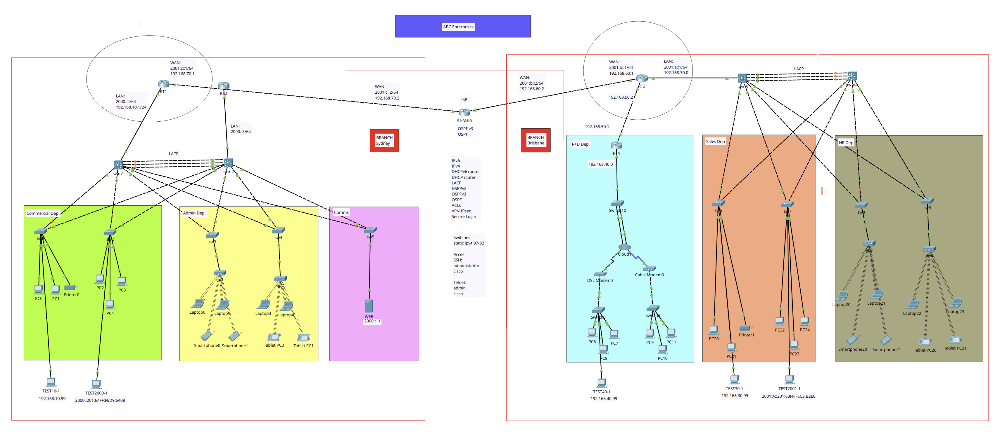
ABC Enterprises is a growing company with headquarters in Melbourne and two branch offices in Sydney and Brisbane. The company currently operates with an outdated network infrastructure that lacks secure, reliable WAN connectivity between sites. The IT department has been tasked with designing, implementing, and securing a new WAN infrastructure that ensures:
- Secure VPN connectivity between all sites.
- Optimised bandwidth usage with reliable routing protocols.
- Proper IPv6 deployment for future scalability.
- Enhanced security mechanisms including firewall rules and access control lists (ACLs).
- Troubleshooting and monitoring tools to detect and rectify network issues efficiently.
As part of the project, you will act as a network engineer responsible for implementing the required WAN connectivity for ABC Enterprises.

Simulation Software & Tools:
Software installed to develop this protect.
- Cisco Packet Tracer 8.2.2
- Ubuntu 24.04 LTS
- Wireshark 4.2.2

Network Design Review & Planning

Network Details

The ABC-Enterprises Network is a WAN Network with two branches, in Sydney and Brisbane. It was designed with ease of configuration, stability, and security in mind. It is a dual-star, high-availability, three-tier network. Both use Ethernet connections, only in Brisbane Branch uses Coax and phone Lines connections.

It implements a dual-stack with a DHCP-router to avoid having dedicated servers. Redundancy is provided by LACP on the switches and HSRP (only Sydney) on the routers. Additionally, LACP provides three communication lanes to increase bandwidth. Communication between LAN networks over internet is provided by OSPF.

For security, ACLs are implemented to allow only IP traffic from the company's networks. IPsec VPN is also used as a data encapsulation and encryption method. Finally, PPP Authentication and CHAP are implemented as an automatic authentication method between the routers.

My network doesn't support PPP because the WAN connections are Ethernet. PPP requires serial connections. Additionally, PPP isn't compatible with HSRP. So I used the reference network given in class.

Firewall & single-port tests and Dynamic NAT were performed on the files submitted in class due to extra complexity over my network.

Topology and type
- Sydney Branch:
  - Type: WAN
  - Topology: Dual-Star high availability
  - Architecture: 3-Tier
- Brisbane Branch:
  - Type: LAN
  - Topology: Star

Network Nodes
Device | Name | Network | Device | Name | Network
Router 1 | RT1 | Sydney | Router 2 | RT2 | Sydney
Switch 1 | sw1 | Sydney | Switch 2 | sw2 | Sydney
Switch 3 | sw3 | Sydney | Switch 4 | sw4 | Sydney
Switch 5 | sw5 | Sydney | Switch ML1 | sw11 | Sydney
Switch ML2 | sw12 | Sydney | Router 3 | RT3 | Brisbane
Router 4 | RT4 | Brisbane | Switch 6 | sw6 | Brisbane
Switch 7 | sw7 | Brisbane | Switch 8 | sw8 | Brisbane
Switch 9 | sw9 | Brisbane | Switch 10 | sw10 | Brisbane
Switch ML3 | sw13 | Brisbane | Switch ML4 | sw14 | Brisbane
Router Main | RT-M | ISP | - | - | -

Network Details – Sydney Branch
Device | Details | Protocols IPv6 | Protocols IPv4 | Access
RT-M | WAN:  2001:c::2/64  192.168.70.2 | OSPFv3 | OSPF | Password Encryption  (RSA)  Local:  admin  SSH:  administrator  cisco  Telnet:  admin  Cisco  FTP  cisco  cisco
RT1 | WAN:  2001:c::1/64  192.168.70.1  LAN:  2000::2/64  192.168.10.1/24  Gateway  2000::210:11FF:FE09:4ED  192.168.10.99  DNS:  2000::10  192.168.10.10 | DHCPv6 router  HSRPv2  OSPFv3 | DHCP router  VPN Ipsec  ACL
RT2 | LAN:  2000::3/64  Gateway:  2000::2  DNS:  2000::10 | DHCPv6 router  HSRPv2 | DHCP router
swm1 | VLAN1:  192.168.10.97 | LAC
swm2 | VLAN1:  192.168.10.98 | LAC
sw1 | VLAN1:  192.168.10.96
sw2 | VLAN1:  192.168.10.95
sw3 | VLAN1:  192.168.10.94
sw4 | VLAN1:  192.168.10.93
sw5 | VLAN1:  192.168.10.92

Network Details – Brisbane Branch
Device | Details | Protocols IPv6 | Protocols IPv4 | Access
RT-M | WAN:  2001:b::2/64  192.168.60.2 | OSPFv3 | OSPF | Password Encryption  (RSA)  Local:  admin  SSH:  administrator  cisco  Telnet:  admin  Cisco
RT3 | WAN:  2001:b::1/64  192.168.60.1  LAN:  2001:a::1/64  192.168.30.0  Gateway  2001:a::1  DNS:  2001:a::10  192.168.30.10 | DHCPv6 router  HSRPv2  OSPFv3 | DHCP router  VPN Ipsec  ACL
RT4 | LAN:  192.168.40.0  Gateway:  192.168.40.1  DNS:  192.168.40.10 |  | DHCP router
swm3 | VLAN1:  192.168.30.97 | LAC
swm4 | VLAN1:  192.168.30.98 | LAC
sw6 | VLAN1:  192.168.30.96
sw7 | VLAN1:  192.168.30.95
sw8 | VLAN1:  192.168.30.94
sw9 | VLAN1:  192.168.30.93
sw10 | VLAN1:  192.168.40.92

Sydney Branch Network
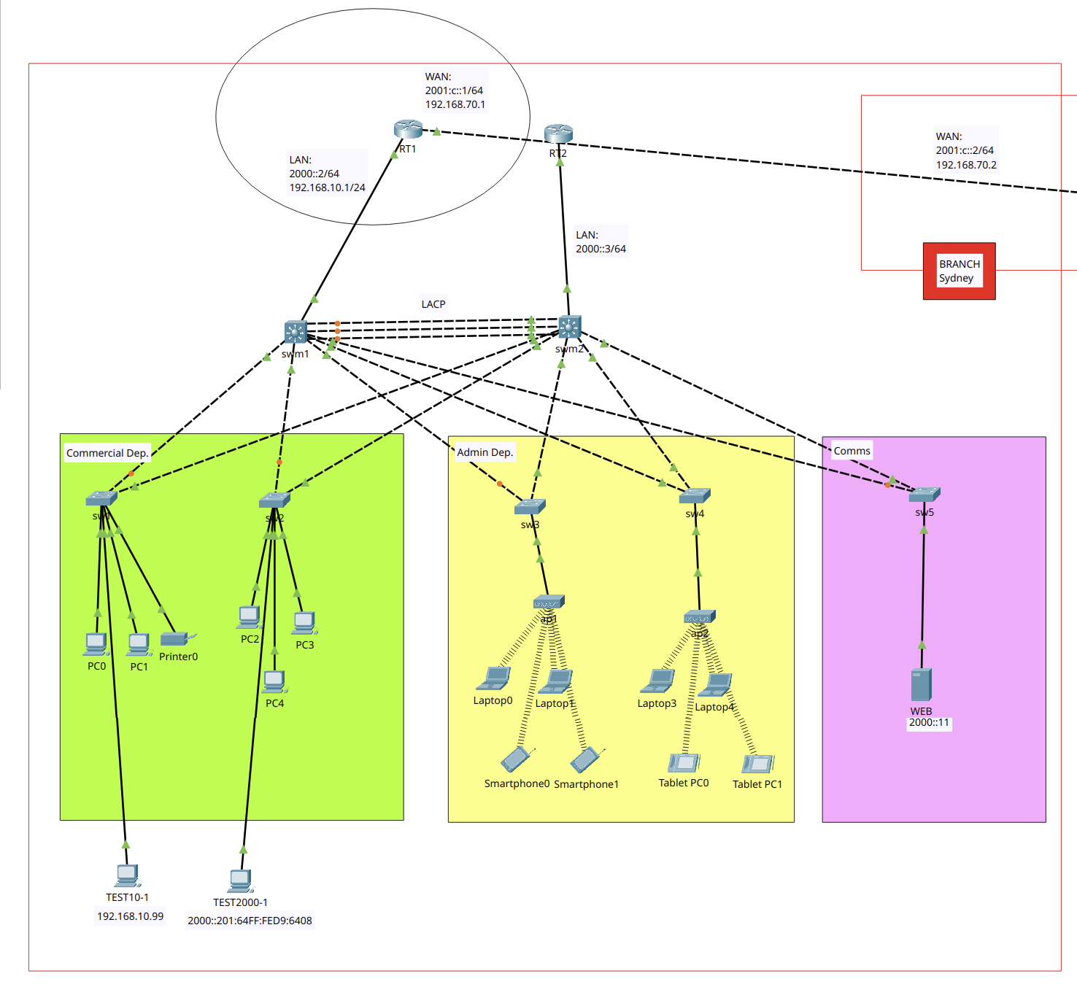

Brisbane Branch Network
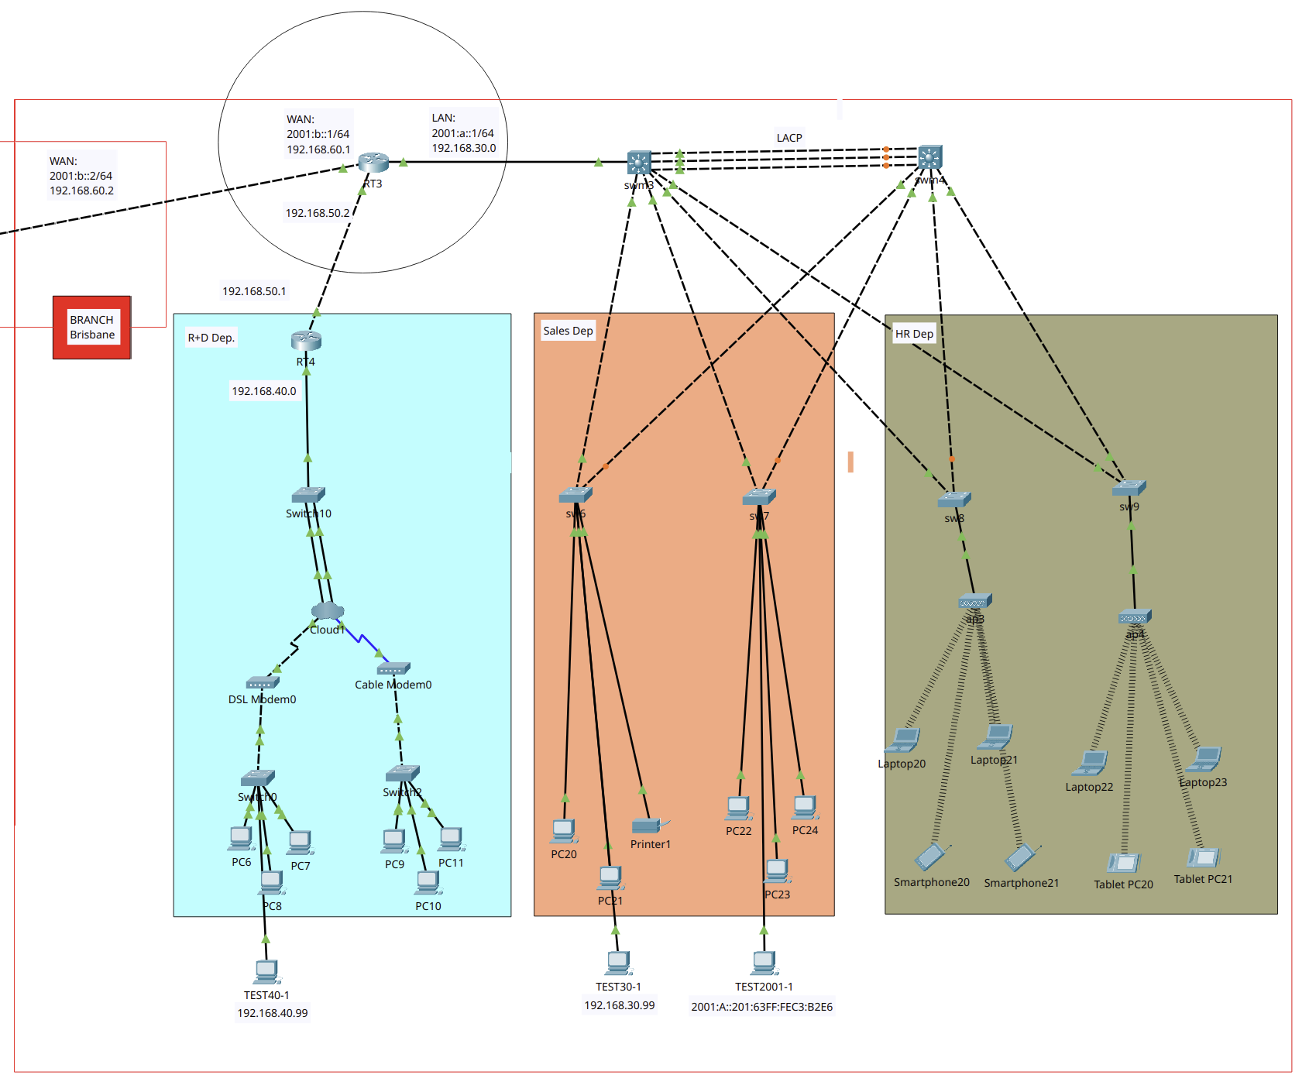

WAN Configuration

Installation Plan
- Implement Network Topology
- Implement Secure Access by SSH & Telnet
- Implement Additional Protocols: DHCPv6, IPV6
- Implement Additional Protocols: LACP
- Implement Additional Protocols: HSRPv2 IPv6
- Implement Additional Protocols: WEB Server
- Implement Additional Protocols: OSPFv3
- Implement Additional Protocols: DualStack, DHCP
- Implement Additional Protocols: OSPF
- Implement WAN protocols: Extended Access Control List (ACL)
- Implement WAN Protocols: VPN Site-To-Site over IPv4
- Implement WAN Protocols: Encapsulation PPP over IPv4
- Implement WAN Protocols: Dynamic NAT over IPv4

Legal & security: Policies and Procedures
- Service Password Encryption
- Mandatory Login Password
- VPN Site-to-Site
- Access Control Lists (ACLs)
- Secure Remote Access to infrastructure

Troubleshooting & Testing

- Testing LAN Connectivity (IPv4/IPv6)
- Testing WAN Connectivity (IPv4/IPv6)
- Testing Secure Access SSH & Telnet - Local
- Testing DHCP/DHCPv6 (IPv4/IPv6)
- Testing LACP (IPv6)
- Testing HSRPv2 (IPv6)
- Testing OSPF/OSPFv3 (IPv4/IPv6)
- Testing ACL (IPv4)
- Testing VPN Site-To-Site (IPv4)
- Testing Encapsulation PPP (IPv4)
- Testing Firewall & Single-port
- Logging Network
- Dynamic NAT

Summary Technologies & Protocols

Bibliography

WAN Configuration

Installation Plan

Implement Network Topology

Rename all devices:
Device Type | Quantity | Device Type | Quantity
Router | 5 | Switch | 14
PC | 20 | Laptop | 8
Smartphone | 4 | Tablet | 4
Server | 1 | Printer | 2
W Access Point | 4 | Modem | 2

3. Additional Protocols: DHCPv6, IPV6

Router 1 (RT1)
Firstly, IPv6 will be enable and then DHCPv6 will be set up
enable
configure terminal
hostname RT1
ipv6 unicast-routing
interface gigabitEthernet 0/0
ipv6 address 2000::2/64
no shutdown
ipv6 dhcp pool STATEFUL_POOL
domain-name milestones.com
dns-server 2000::10
prefix-delegation pool STATEFUL_POOL
exit
interface gigabitEthernet 0/0
ipv6 dhcp server STATEFUL_POOL
ipv6 nd managed-config-flag
exit
Do wr
exit
exit

Router 3 (RT3)
enable
configure terminal
hostname RT3
ipv6 unicast-routing
interface gigabitEthernet 0/2
ipv6 address 2001:a::1/64
no shutdown
ipv6 dhcp pool STATEFUL_POOL
domain-name milestones.com
dns-server 2001:a::10
prefix-delegation pool STATEFUL_POOL
exit

interface gigabitEthernet 0/2
ipv6 dhcp server STATEFUL_POOL
ipv6 nd managed-config-flag
exit
Do wr
exit
exit

4. Implement Additional Protocols: LACP

Implementation of Link Aggregation Control Protocol (LACP) on links:
- swm1 gigabitEthernet 1/0/22 <—> swm2 gigabitEthernet 1/0/22
- swm1 gigabitEthernet 1/0/23 <—> swm2 gigabitEthernet 1/0/23
- swm1 gigabitEthernet 1/0/24 <—> swm2 gigabitEthernet 1/0/24
- swm3 gigabitEthernet 1/0/22 <—> swm4 gigabitEthernet 1/0/22
- swm3 gigabitEthernet 1/0/23 <—> swm4 gigabitEthernet 1/0/23
- swm3 gigabitEthernet 1/0/24 <—> swm4 gigabitEthernet 1/0/24
The LACP link will be the channel-group number 1 on all switches.

Switch Main 1 (swm1)
enable
configure terminal
interface range gigabitEthernet 1/0/22, gigabitEthernet 1/0/23, gigabitEthernet 1/0/24
channel-group 1 mode active
exit
interface Port-channel 1
switchport mode trunk
exit
do wr
exit
exit

enable
configure terminal
interface gigabitEthernet 1/0/1
switchport
no shutdown
Exit
Do wr
exit

Switch Main 2 (swm2)
enable
configure terminal
interface range gigabitEthernet 1/0/22, gigabitEthernet 1/0/23, gigabitEthernet 1/0/24
channel-group 1 mode passive
exit
interface Port-channel 1
switchport mode trunk
exit
do wr
exit
exit

enable
configure terminal
interface gigabitEthernet 1/0/1
switchport
no shutdown
Exit
Do wr
exit

Switch Main 3 (swm3)
enable
configure terminal
interface range gigabitEthernet 1/0/22, gigabitEthernet 1/0/23, gigabitEthernet 1/0/24
channel-group 1 mode active
exit
interface Port-channel 1
switchport mode trunk
exit
do wr
exit
exit

enable
configure terminal
interface gigabitEthernet 1/0/1
switchport
no shutdown
Exit
Do wr
exit

Switch Main 4 (swm4)
enable
configure terminal
interface range gigabitEthernet 1/0/22, gigabitEthernet 1/0/23, gigabitEthernet 1/0/24
channel-group 1 mode passive
exit
interface Port-channel 1
switchport mode trunk
exit
do wr
exit
exit

enable
configure terminal
interface gigabitEthernet 1/0/1
switchport
no shutdown
Exit
Do wr
exit

5. Implement Additional Protocols: HSRPv2 IPv6

Links:
- HSRP IPv6 Address: 2000::1/64
- RT1 gigabitEthernet 0/0 <—> 2000::2 (primary router)
- RT2 gigabitEthernet 0/0 <—> 2000::3 (secondary router)

Checking
- show running-config | include standby
- show standby

Router 1 (RT1)
enable
configure terminal
interface gigabitEthernet 0/0
ipv6 address 2000::2/64
standby version 2
standby 1 ipv6 autoconfig
standby 1 priority 120
no shutdown
Exit
Do wr
exit
exit

Router 2 (RT2)
Firstly, It will be setting up RT2 same as RT1 then RT2 will be marked as a secondary router.
enable
configure terminal
hostname RT2
ipv6 unicast-routing

interface gigabitEthernet 0/0
ipv6 address 2000::3/64
no shutdown
ipv6 dhcp pool STATEFUL_POOL
domain-name milestones.com
dns-server 2000::10
prefix-delegation pool STATEFUL_POOL
exit
interface gigabitEthernet 0/0
ipv6 dhcp server STATEFUL_POOL
ipv6 nd managed-config-flag
exit
Do wr
exit
exit

enable
configure terminal
interface gigabitEthernet 0/0
ipv6 address 2000::3/64
standby version 2
standby 1 ipv6 autoconfig
no shutdown
Exit
Do wr
exit
exit

6. Additional Protocols: WEB Server

Firstly, enable HTTP and HTTPs services and disable all other services, then edit index.html
<html>
<center><font size='+2' color='blue'>ABC ENTERPRISES Sydney</font></center>
<hr>Welcome to ABC Enterprises WEB server. This is a project for an assessment task 2 - May 2025.
<p>Quick Links:
<br><a href='helloworld.html'>A small page</a>
<br><a href='copyrights.html'>Copyrights</a>
<br><a href='image.html'>Image page</a>
<br><a href='cscoptlogo177x111.jpg'>Image</a>
</html>

7. Additional Protocols: OSPFv3

Links:
- RT1 Network gigabitEthernet 0/0
- RT1 gigabitEthernet 0/1 <—> RT-M gigabitEthernet 0/0
- RT3 Network gigabitEthernet 0/2
- RT-M gigabitEthernet 0/2 <—> RT-3 gigabitEthernet 0/1
Addressing:
- RT1 —> 2000::2/64
- RT1 <—> RT-M, 2001:c::1/64
- RT-M <—> RT1, 2001:c::2/64
- RT3 —> 2001:a::1/64
- RT-M <—> RT3, 2001:b::2/64
- RT3 <—> RT-M, 2001:b::1/64
Checking, reload:
- show ipv6 ospf neighbor
- clear ipv6 ospf process
- Show ipv6 ospf database

Router 1 (RT1)
!general config, IP link
enable
configure terminal
interface gigabitEthernet 0/1
ipv6 address 2001:c::1/64
no shutdown
exit

!enabling unicast and giving id
ipv6 unicast-routing
ipv6 router OSPF 10
router-id 1.1.1.1
exit

!enabling OSPF on network link
interface gigabitEthernet 0/0
ipv6 OSPF 10 area 0
exit

!enabling OSPF between RT1 and RT-M
interface gigabitEthernet 0/1
ipv6 OSPF 10 area 0
exit
do wr

Router Main (RT-Main)
!general config, IP link
enable
configure terminal
interface gig0/0
ipv6 address 2001:c::2/64
no shutdown
exit
interface gig0/2
ipv6 address 2001:b::2/64
no shutdown
exit

!enabling unicast and giving router id
ipv6 unicast-routing
ipv6 router OSPF 10
router-id 2.2.2.2
exit

!enabling OSPF between RT-Main and RT1
interface gig0/0
ipv6 OSPF 10 area 0
exit

!enabling OSPF between RT-Main and RT3
interface gig0/2
ipv6 OSPF 10 area 0
exit
do wr

Router 3 (RT3)
!general config, IP link
enable
configure terminal
interface gigabitEthernet 0/1
ipv6 address 2001:b::1/64
no shutdown
exit

!enabling unicast and giving router id
ipv6 unicast-routing
ipv6 router OSPF 10
router-id 3.3.3.3
exit

!enabling OSPF on network link
interface gigabitEthernet 0/2
ipv6 OSPF 10 area 0
exit

!enabling OSPF between RT3 and RT-Main
interface gigabitEthernet 0/1
ipv6 OSPF 10 area 0
exit
do wr
exit

8. Implement Additional Protocols: DualStack, DHCP

Router 1 (RT1)
!setting up IPv4, dhcp
enable
configure terminal
do wr
interface gigabitEthernet 0/0
ip address 192.168.10.1 255.255.255.0
no shutdown
exit
do wr
ip dhcp pool STATEFUL_POOL
network 192.168.10.0 255.255.255.0
default-router 192.168.10.1
dns-server 192.168.10.10
exit
do wr

Router 3 (RT3)
!setting up ipv4, dhcp
enable
configure terminal
do wr
interface gigabitEthernet 0/2
ip address 192.168.30.1 255.255.255.0
no shutdown
exit
do wr
ip dhcp pool STATEFUL_POOL
network 192.168.30.0 255.255.255.0
default-router 192.168.30.1
dns-server 192.168.30.10
exit
do wr

Router 4 (RT4)
Enabling IPv4 to ensure full compatibility with DSL protocol connection.
!setting up IPv4, dhcp
enable
configure terminal
hostname RT4
do wr
interface gigabitEthernet 0/0
ip address 192.168.40.1 255.255.255.0
no shutdown
exit
do wr
ip dhcp pool STATEFUL_POOL
network 192.168.40.0 255.255.255.0
default-router 192.168.40.1
dns-server 192.168.40.10
exit
do wr

9. Additional Protocols: OSPF

Links:
- RT1 Network gigabitEthernet 0/0
- RT1 gigabitEthernet 0/1 <—> RT-M gigabitEthernet 0/0
- RT3 Network gigabitEthernet 0/2
- RT-M gigabitEthernet 0/2 <—> RT-3 gigabitEthernet 0/1
- RT4 Network gigabitEthernet 0/0
- RT4 gigabitEthernet 0/1 <—> RT-3 gigabitEthernet 0/0

Addressing:
- RT1 —> 192.168.10.1
- RT1 <—> RT-M, 192.168.70.1
- RT-M <—> RT1, 192.168.70.2
- RT3 —> 192.168.30.1
- RT-M <—> RT3, 192.168.60.2
- RT3 <—> RT-M, 192.168.60.1
- RT4 —> 192.168.40.1
- RT3 <—> RT4, 192.168.50.1
- RT4 <—> RT3, 192.168.50.2

Checking, reload:
- show ip ospf neighbor
- show ip ospf database
- clear ip ospf process

Router 1 (RT1)

!general config, IP link

enable

configure terminal

interface gigabitEthernet 0/1

ip address 192.168.70.1 255.255.255.0

no shutdown

exit

!enabling OSPF

router ospf 20

network 192.168.70.0 0.0.0.255 area 0

network 192.168.10.0 0.0.0.255 area 0

exit

do wr

exit

exit

Router Main (RT-M)

!general config, IP link

enable

configure terminal

interface gigabitEthernet 0/0

ip address 192.168.70.2 255.255.255.0

no shutdown

exit

interface gigabitEthernet 0/2

ip address 192.168.60.2 255.255.255.0

no shutdown

exit

!enabling OSPF

router ospf 20

network 192.168.70.0 0.0.0.255 area 0

network 192.168.60.0 0.0.0.255 area 0

exit

do wr

exit

exit

Router 3 (RT3)

!general config, IP link

enable

configure terminal

interface gigabitEthernet 0/1

ip address 192.168.60.1 255.255.255.0

no shutdown

exit

interface gigabitEthernet 0/0

ip address 192.168.50.2 255.255.255.0

no shutdown

exit

!enabling OSPF

router ospf 20

network 192.168.60.0 0.0.0.255 area 0

network 192.168.30.0 0.0.0.255 area 0

network 192.168.50.0 0.0.0.255 area 0

network 192.168.40.0 0.0.0.255 area 0

exit

do wr

exit

exit

Router 4 (RT4)

!general config, IP link

enable

configure terminal

interface gigabitEthernet 0/1

ip address 192.168.50.1 255.255.255.0

no shutdown

exit

!enabling OSPF

router ospf 20
router-id 4.4.4.4

network 192.168.50.0 0.0.0.255 area 0

network 192.168.40.0 0.0.0.255 area 0

exit

do wr

exit

exit

11. WAN Protocols: VPN Site-To-Site over IPv4

VPN IPsec (Internet Protocol Security): Creates encrypted connections over the Internet between two networks (site-to-site), protecting the confidentiality and integrity of data.

Compatible hardware:
- Router model No 2911
- Switche model No 2690

“checking VPN Ipsec: look for technology: ipbasek9:permanent and secirityk9:evaluation”
show version
show crypto IPsec sa

Router 1 (RT1)
!enabling security technology package
license boot module c2900 technology-package securityk9

do write
exit

copy run start

reload

enable

configure terminal

crypto isakmp policy 10

encr aes 256

authentication pre-share

group 5

!

crypto isakmp key vpnpass address 192.168.60.1

!

crypto isakmp key vpnpass address 192.168.50.1

!

crypto ipsec transform-set VPN-SET esp-aes esp-sha-hmac

!

crypto map VPN-MAP 10 ipsec-isakmp

description VPN connection to Branch_Router

set peer 192.168.60.1

set peer 192.168.50.1

set transform-set VPN-SET

match address 110

!

interface GigabitEthernet0/1

crypto map VPN-MAP

!

end

copy run start

Router 3 (RT3)
!enabling security technology package
license boot module c2900 technology-package securityk9

do write
exit

copy run start

reload

enable

configure terminal

crypto isakmp policy 10

encr aes 256

authentication pre-share

group 5

!

crypto isakmp key vpnpass address 192.168.70.1

!
crypto isakmp key vpnpass address 192.168.50.1

!
crypto ipsec transform-set VPN-SET esp-aes esp-sha-hmac

!

crypto map VPN-MAP 10 ipsec-isakmp

description VPN connection to Branch_Router

set peer 192.168.70.1

set peer 192.168.50.1

set transform-set VPN-SET

match address 110

!

interface GigabitEthernet0/1

crypto map VPN-MAP

!

end

copy run start

Router 4 (RT4)
!enabling security technology package
license boot module c2900 technology-package securityk9

do write
exit

copy run start

reload

enable

configure terminal

crypto isakmp policy 10

encr aes 256

authentication pre-share

group 5

!

crypto isakmp key vpnpass address 192.168.60.1

!

crypto isakmp key vpnpass address 192.168.70.1

!

crypto ipsec transform-set VPN-SET esp-aes esp-sha-hmac

!

crypto map VPN-MAP 10 ipsec-isakmp

description VPN connection to Branch_Router

set peer 192.168.70.1

set peer 192.168.60.1

set transform-set VPN-SET

match address 110

!

interface GigabitEthernet0/1

crypto map VPN-MAP

!

end

copy run start

12. Implement WAN Protocols: Encapsulation PPP over IPv4

My network doesn't support PPP because the connections are Ethernet. PPP requires serial connections. Additionally, PPP isn't compatible with HSRP. So I'll use the reference network given in class.

Applied on Routers R1, R2, R3 and ISP. Using of CHAP as an automatic authentication method instead of PAP.
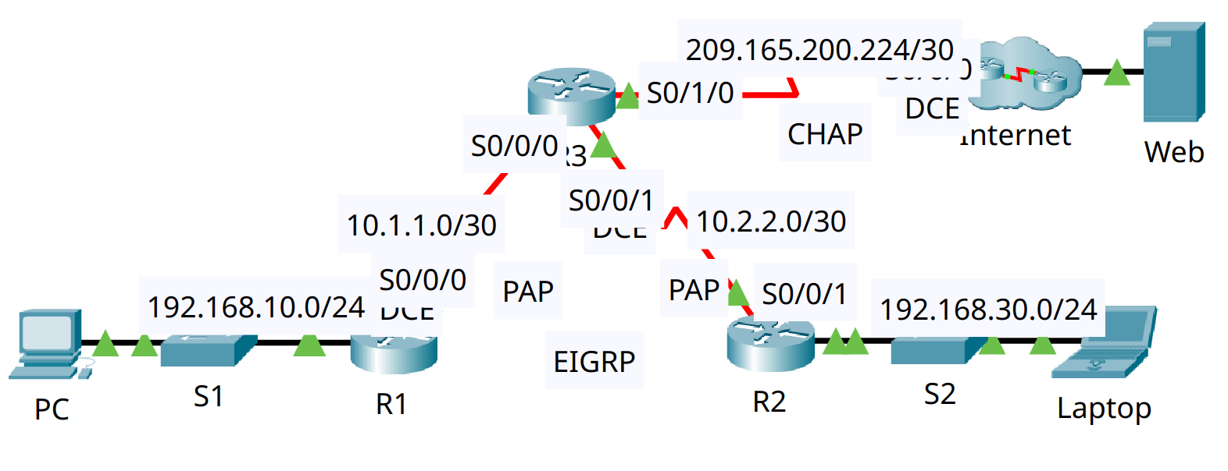
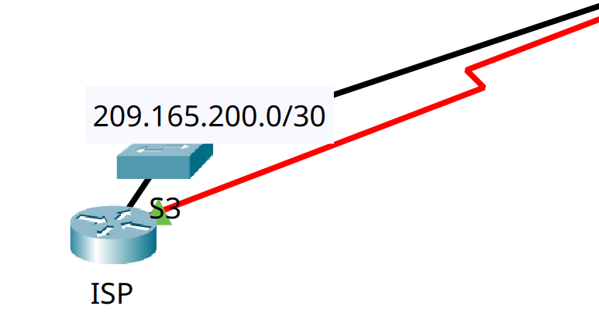

Summary configutarion:
!setting up Encapsulation Method
interface <WAN_to_target>
encapsulation ppp
!

!setting up PPP Authentication
username <Router_target> secret cisco
interface SALIDA
ppp authentication chap

Implementation PPP

R1
interface serial 0/0/0
encapsulation ppp
exit
username R3 secret cisco
interface serial 0/0/0
ppp authentication chap
exit

R2
interface serial 0/0/1
encapsulation ppp
exit
username R3 secret cisco
interface serial 0/0/1
ppp authentication chap
exit

R3
interface serial 0/0/0
encapsulation ppp
exit

interface serial 0/0/1
encapsulation ppp
exit

interface serial 0/1/0
encapsulation ppp
exit

!second step on R3
username R1 secret cisco
interface serial 0/0/0
ppp authentication chap
exit
!
username R2 secret cisco
interface serial 0/0/1
ppp authentication chap
exit
!
username ISP secret cisco
interface serial 0/1/0
ppp authentication chap
exit

ISP
interface serial 0/0/0
encapsulation ppp
exit
username R3 secret cisco
interface serial 0/0/0
ppp authentication chap
exit

13. Implement WAN Protocols: Dynamic NAT over IPv4

Dynamic NAT tests were performed on the file submitted in class due to extra complexity over my network.

Network:
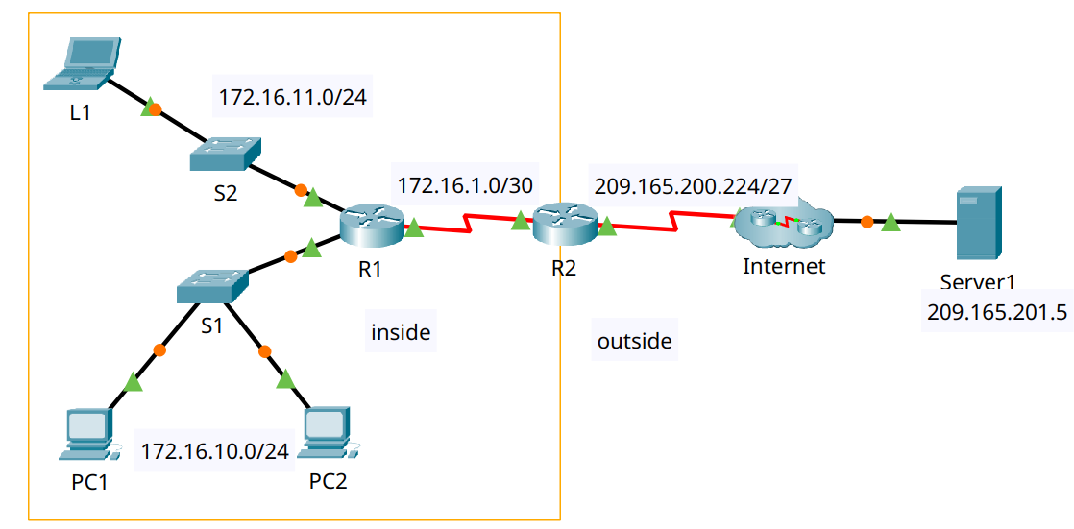

Implementation
- Checking:
  - show ip nat translations

In ACL list we need to use 172.16.0.0 for allow traffic from 172.16.11.0/24 and 172.16.10.0/24 but their wildcard IS NOT 0.0.0.255, it is 0.0.255.255 because this rule will be use for both networks that shared only two first positions 172.16.X.X

Network Security Implementation

10. Apply Access Control Lists (ACLS)
Implementing ALC over IPv4 networks.
Checking:
- show access-lists

Router 1 (RT1)
access-list 110 permit ip 192.168.10.0 0.0.0.255 192.168.30.0 0.0.0.255

access-list 110 permit ip 192.168.10.0 0.0.0.255 192.168.40.0 0.0.0.255

access-list 110 permit ip 192.168.30.0 0.0.0.255 192.168.10.0 0.0.0.255

access-list 110 permit ip 192.168.40.0 0.0.0.255 192.168.10.0 0.0.0.255
!
copy run start

Router 3 (RT3)
access-list 110 permit ip 192.168.30.0 0.0.0.255 192.168.10.0 0.0.0.255

access-list 110 permit ip 192.168.30.0 0.0.0.255 192.168.40.0 0.0.0.255

access-list 110 permit ip 192.168.10.0 0.0.0.255 192.168.30.0 0.0.0.255

access-list 110 permit ip 192.168.40.0 0.0.0.255 192.168.30.0 0.0.0.255
!
copy run start

Router 4 (RT4)
access-list 110 permit ip 192.168.40.0 0.0.0.255 192.168.10.0 0.0.0.255

access-list 110 permit ip 192.168.40.0 0.0.0.255 192.168.30.0 0.0.0.255

access-list 110 permit ip 192.168.10.0 0.0.0.255 192.168.40.0 0.0.0.255

access-list 110 permit ip 192.168.30.0 0.0.0.255 192.168.40.0 0.0.0.255
!
copy run start

2. Secure Access Switches By SSH & Telnet

Checking:
- show running-config
- ssh -l administrator <ip_vlan1>
- telnet <ip_vlan1>
- service password-encryption

Switch 1 (sw1)
enable
configure terminal
!enabling password
enable password admin
!
!enabling vlan
interface VLAN 1
ip address 192.168.10.96 255.255.255.0
no shutdown
exit
do wr

!enabling password on virtual terminals
service password-encryption
username administrator password cisco
ip domain-name milestones.com
hostname sw1
crypto key generate rsa general-keys modulus 1024
!
ip ssh version 2
line vty 5 15
transport input ssh
login local
exit
!
line vty 0 4
transport input telnet
password cisco
login
!
exit
!
do wr
!
exit
!

Switch 2 (sw2)
enable
configure terminal
!enabling password
enable password admin
!
!enabling vlan
interface VLAN 1
ip address 192.168.10.95 255.255.255.0
no shutdown
exit
do wr

!enabling password on virtual terminals
service password-encryption
username administrator password cisco
ip domain-name milestones.com
hostname sw2
crypto key generate rsa general-keys modulus 1024
!
ip ssh version 2
line vty 5 15
transport input ssh
login local
exit
!
line vty 0 4
transport input telnet
password cisco
login
!
exit
!
do wr
!
exit
!

Switch 3 (sw3)
enable
configure terminal
!enabling password
enable password admin
!
!enabling vlan
interface VLAN 1
ip address 192.168.10.94 255.255.255.0
no shutdown
exit
do wr

!enabling password on virtual terminals
service password-encryption
username administrator password cisco
ip domain-name milestones.com
hostname sw3
crypto key generate rsa general-keys modulus 1024
!
ip ssh version 2
line vty 5 15
transport input ssh
login local
exit
!
line vty 0 4
transport input telnet
password cisco
login
!
exit
!
do wr
!
exit
!

Switch 4 (sw4)
enable
configure terminal
!enabling password
enable password admin
!
!enabling vlan
interface VLAN 1
ip address 192.168.10.93 255.255.255.0
no shutdown
exit
do wr

!enabling password on virtual terminals
service password-encryption
username administrator password cisco
ip domain-name milestones.com
hostname sw4
crypto key generate rsa general-keys modulus 1024
!
ip ssh version 2
line vty 5 15
transport input ssh
login local
exit
!
line vty 0 4
transport input telnet
password cisco
login
!
exit
!
do wr
!
exit
!

Switch 5 (sw5)

enable
configure terminal
!enabling password
enable password admin
!
!enabling vlan
interface VLAN 1
ip address 192.168.10.92 255.255.255.0
no shutdown
exit
do wr

!enabling password on virtual terminals
service password-encryption
username administrator password cisco
ip domain-name milestones.com
hostname sw5
crypto key generate rsa general-keys modulus 1024
!
ip ssh version 2
line vty 5 15
transport input ssh
login local
exit
!
line vty 0 4
transport input telnet
password cisco
login
!
exit
!
do wr
!
exit
!

Multi-layer Switch 1 (swm1)
Before configure, install AC-POWER-SUPPLY module.
enable
configure terminal
!enabling password
enable password admin
!
!enabling vlan
interface VLAN 1
ip address 192.168.10.98 255.255.255.0
no shutdown
exit
do wr

!enabling password on virtual terminals
service password-encryption
username administrator password cisco
ip domain-name milestones.com
hostname swm1
crypto key generate rsa general-keys modulus 1024
!
ip ssh version 2
line vty 5 15
transport input ssh
login local
exit
!
line vty 0 4
transport input telnet
password cisco
login
!
exit
!
do wr
!
exit
!

Multi-layer Switch 2 (swm2)
Before configure, install AC-POWER-SUPPLY module.
enable
configure terminal
!enabling password
enable password admin
!
!enabling vlan
interface VLAN 1
ip address 192.168.10.97 255.255.255.0
no shutdown
exit
do wr

!enabling password on virtual terminals
service password-encryption
username administrator password cisco
ip domain-name milestones.com
hostname swm2
crypto key generate rsa general-keys modulus 1024
!
ip ssh version 2
line vty 5 15
transport input ssh
login local
exit
!
line vty 0 4
transport input telnet
password cisco
login
!
exit
!
do wr
!
exit
!

Switch 6 (sw6)
enable
configure terminal
!enabling password
enable password admin
!
!enabling vlan
interface VLAN 1
ip address 192.168.30.96 255.255.255.0
no shutdown
exit
do wr

!enabling password on virtual terminals
service password-encryption
username administrator password cisco
ip domain-name milestones.com
hostname sw6
crypto key generate rsa general-keys modulus 1024
!
ip ssh version 2
line vty 5 15
transport input ssh
login local
exit
!
line vty 0 4
transport input telnet
password cisco
login
!
exit
!
do wr
!
exit
!

Switch 7 (sw7)
enable
configure terminal
!enabling password
enable password admin
!
!enabling vlan
interface VLAN 1
ip address 192.168.30.95 255.255.255.0
no shutdown
exit
do wr

!enabling password on virtual terminals
service password-encryption
username administrator password cisco
ip domain-name milestones.com
hostname sw7
crypto key generate rsa general-keys modulus 1024
!
ip ssh version 2
line vty 5 15
transport input ssh
login local
exit
!
line vty 0 4
transport input telnet
password cisco
login
!
exit
!
do wr
!
exit
!

Switch 8 (sw8)
enable
configure terminal
!enabling password
enable password admin
!
!enabling vlan
interface VLAN 1
ip address 192.168.30.94 255.255.255.0
no shutdown
exit
do wr

!enabling password on virtual terminals
service password-encryption
username administrator password cisco
ip domain-name milestones.com
hostname sw8
crypto key generate rsa general-keys modulus 1024
!
ip ssh version 2
line vty 5 15
transport input ssh
login local
exit
!
line vty 0 4
transport input telnet
password cisco
login
!
exit
!
do wr
!
exit
!

Switch 9
enable
configure terminal
!enabling password
enable password admin
!
!enabling vlan
interface VLAN 1
ip address 192.168.30.93 255.255.255.0
no shutdown
exit
do wr

!enabling password on virtual terminals
service password-encryption
username administrator password cisco
ip domain-name milestones.com
hostname sw9
crypto key generate rsa general-keys modulus 1024
!
ip ssh version 2
line vty 5 15
transport input ssh
login local
exit
!
line vty 0 4
transport input telnet
password cisco
login
!
exit
!
do wr
!
exit
!

Multi-layer Switch 3 (swm3)
Before configure, install AC-POWER-SUPPLY module.
enable
configure terminal
!enabling password
enable password admin
!
!enabling vlan
interface VLAN 1
ip address 192.168.30.98 255.255.255.0
no shutdown
exit
do wr

!enabling password on virtual terminals
service password-encryption
username administrator password cisco
ip domain-name milestones.com
hostname swm3
crypto key generate rsa general-keys modulus 1024
!
ip ssh version 2
line vty 5 15
transport input ssh
login local
exit
!
line vty 0 4
transport input telnet
password cisco
login
!
exit
!
do wr
!
exit
!

Multi-layer Switch 4 (swm4)
Before configure, install AC-POWER-SUPPLY module.
enable
configure terminal
!enabling password
enable password admin
!
!enabling vlan
interface VLAN 1
ip address 192.168.30.97 255.255.255.0
no shutdown
exit
do wr

!enabling password on virtual terminals
service password-encryption
username administrator password cisco
ip domain-name milestones.com
hostname swm4
crypto key generate rsa general-keys modulus 1024
!
ip ssh version 2
line vty 5 15
transport input ssh
login local
exit
!
line vty 0 4
transport input telnet
password cisco
login
!
exit
!
do wr
!
exit
!

Switch 10
enable
configure terminal
!enabling password
enable password admin
!
!enabling vlan
interface VLAN 1
ip address 192.168.40.97 255.255.255.0
no shutdown
exit
do wr

!enabling password on virtual terminals
service password-encryption
username administrator password cisco
ip domain-name milestones.com
hostname sw10
crypto key generate rsa general-keys modulus 1024
!
ip ssh version 2
line vty 5 15
transport input ssh
login local
exit
!
line vty 0 4
transport input telnet
password cisco
login
!
exit
!
do wr
!
exit
!

2. Secure Access Routers By SSH & Telnet

Checking:
- show running-config
- ssh -l administrator <ip_router>
- telnet <ip_router>
- service password-encryption

Router 1 (RT1)
enable
configure terminal
!enabling password
enable password admin
!
!enabling vlan
interface VLAN 1
ip address 192.168.10.96 255.255.255.0
no shutdown
exit
do wr

!enabling password on virtual terminals
service password-encryption
username administrator password cisco
ip domain-name milestones.com
hostname sw1
crypto key generate rsa general-keys modulus 1024
!
ip ssh version 2
line vty 5 15
transport input ssh
login local
exit
!
line vty 0 4
transport input telnet
password cisco
login
!
exit
!
do wr
!
exit
!

Routers: RT1, RT2, RT3, RT4, RT-M
Use next configuration on all router on this network:

enable
configure terminal
!enabling password
enable password admin
!
!enabling password on virtual terminals
service password-encryption
username administrator password cisco
ip domain-name milestones.com
crypto key generate rsa general-keys modulus 1024
!
ip ssh version 2
line vty 5 15
transport input ssh
login local
exit
!
line vty 0 4
transport input telnet
password cisco
login
!
exit
!
do wr
!
exit
!

Legal & security: Policies and Procedures

ABC Enterprises adopts security technologies to ensure data protection. The company's policies are outlined below.

1. Service Password Encryption
Policy to prevent access to plain-text passwords in network devices. In compliance with standard ISO/IEC 27001.

ISO/IEC 27001 – to safeguarding of authentication credentials and sensitive information stored in system configurations.

2. Mandatory Login Password
Policy on all network devices that requires a login password for any access to routers or switches. In compliance with NIST SP 800-53 (IA-2).

NIST SP 800-53 (IA-2) – apply authentication mechanisms are mandatory to verify user identity prior to access to network infrastructure.

3. VPN Site-to-Site
Policy implements IPSec to protect data in transit between different company branches over internet. In compliance with NIST SP 800-77.

NIST SP 800-77 – provides guidance for the secure deployment of IPsec VPNs in enterprise environments.

4. Access Control Lists (ACLs)
Policy to filter traffic and control access between subnets, enhance internal network security. In compliance with ISO/IEC 27002 (s13)

ISO/IEC 27002 – control and restrics network access to authorized communications only.

5. Secure Remote Access to infrastructure
Policy to protect remote access by Telnet and SSH to network devices using password-protected and encrypted. In compliance with This configuration aligns with: NIST SP 800-5.

NIST SP 800-52 – secure protocols for administrative access and discourages the use of unencrypted communication channels.

Troubleshooting & Testing

1. Testing LAN Connectivity (IPv4/IPv6)

Sydney Branch
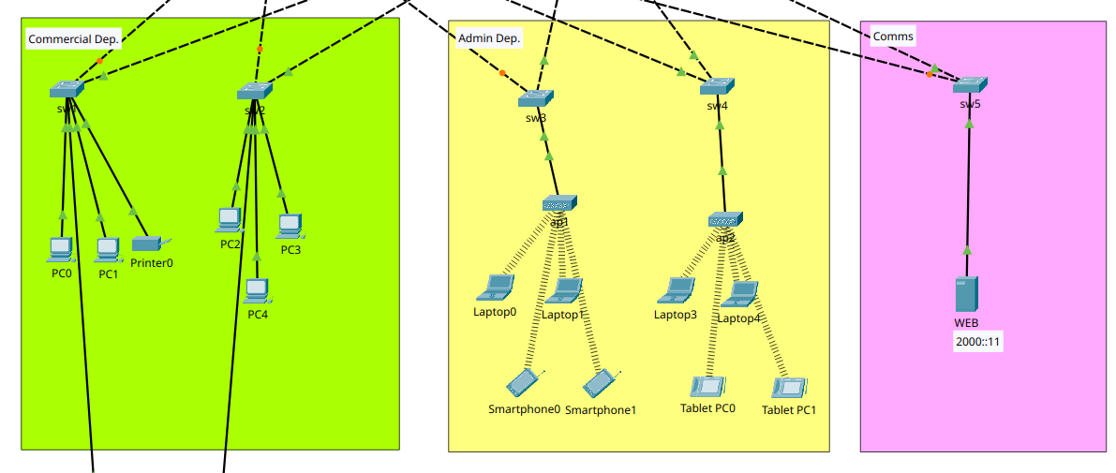
- Connectivity between Commercial and Admin over IPv6
PC0 LAPTOP0
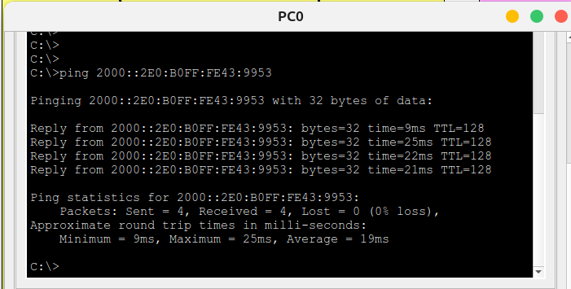

- Connectivity between Commercial and Admin over IPv4
PC0 LAPTOP0
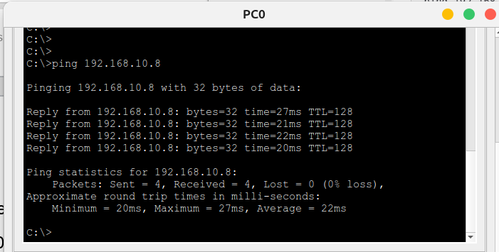

- Connectivity between Commercial and Comms over IPv6
WEB PC0
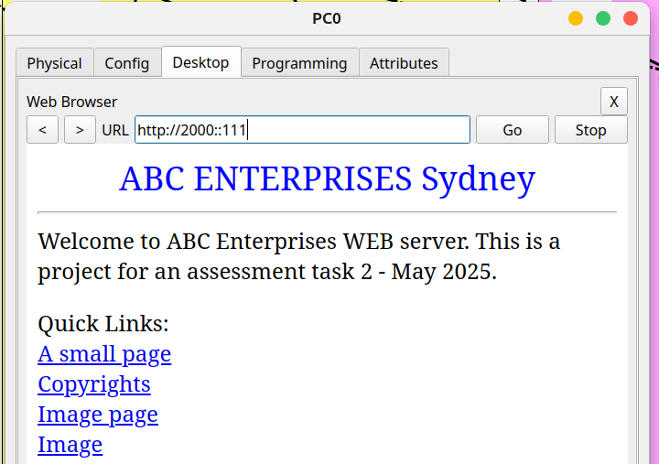

- Connectivity between Commercial and Comms over IPv4
WEB PC0
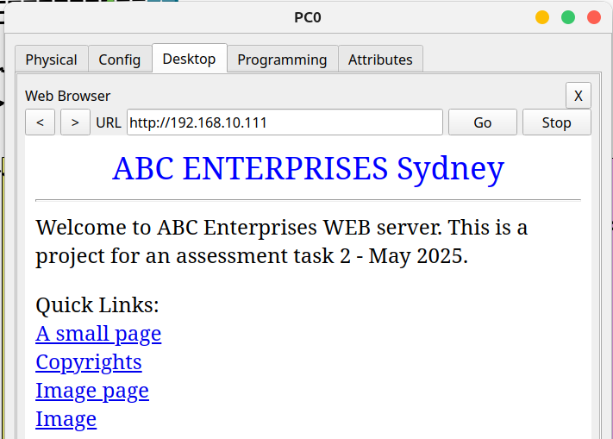

- Connectivity between Admin and Comms over IPv6
LAPTOP0 WEB
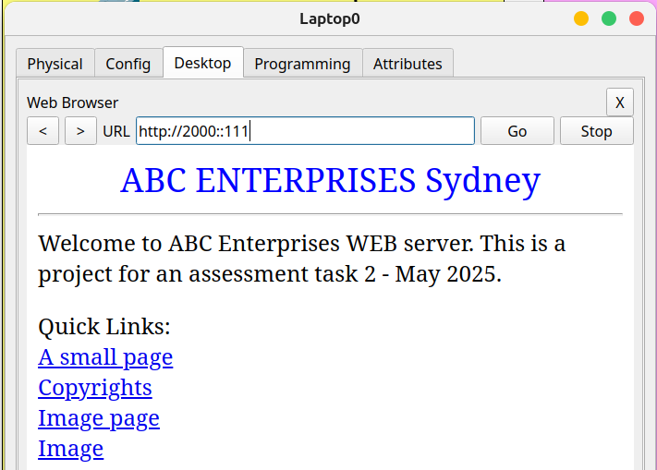

- Connectivity between Admin and Comms over IPv4
LAPTOP0 WEB
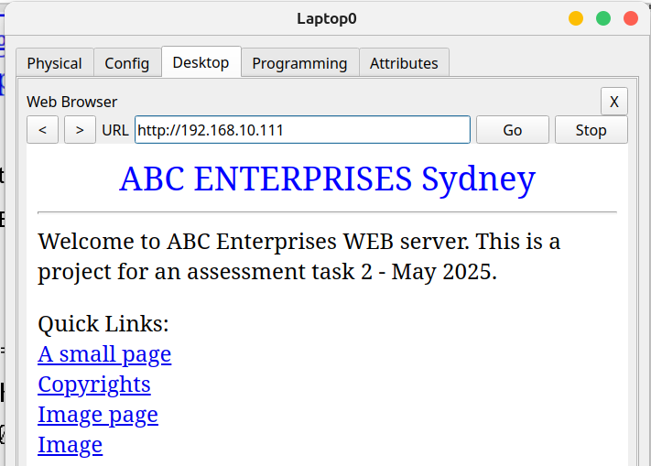

Brisbane Branch

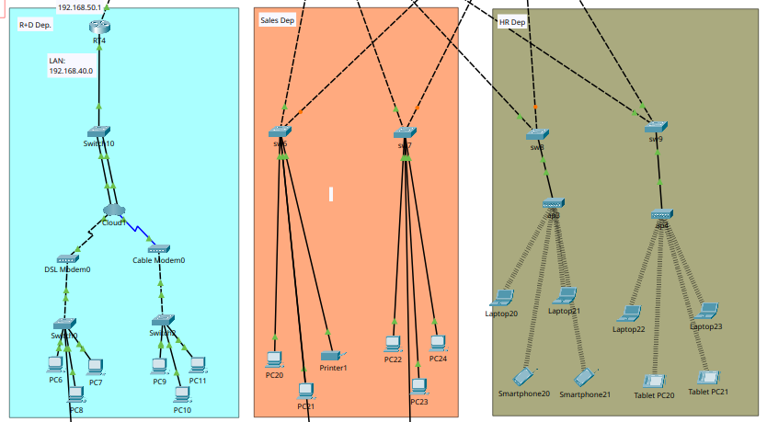

- Connectivity between Sales and HR over IPv6
PC20 LAPTOP20
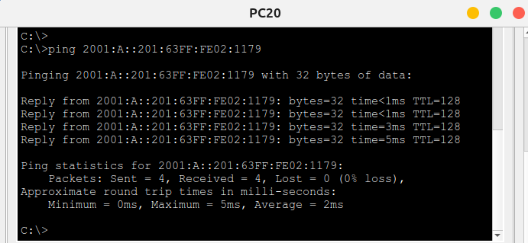

- Connectivity between Sales and HR over IPv4
PC20 LAPTOP20
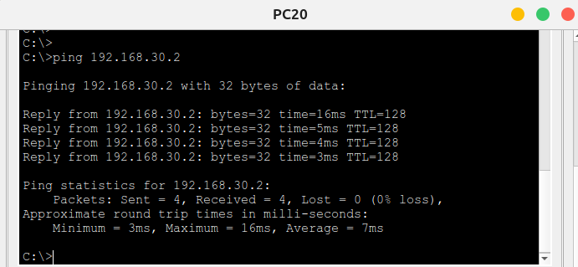

- Connectivity between Sales and R+D over IPv4
PC20 PC6
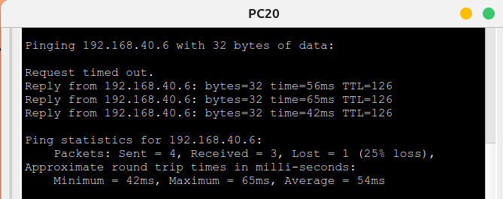

- Connectivity between HR and R+D over IPv4
LAPTOP20 PC6

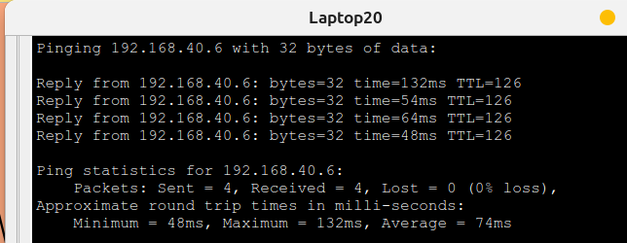
2. Testing WAN Connectivity (IPv4/IPv6)

- Connectivity between Sydney Branch and Brisbane Branch
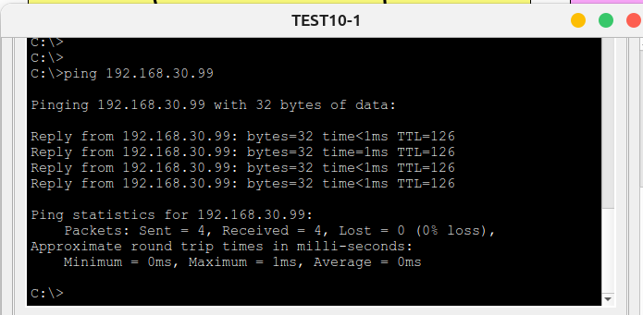
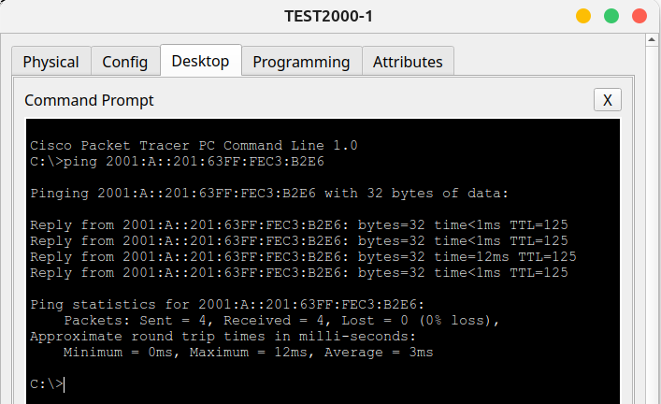

- Connectivity between Brisbane Branch and Sydney Branch
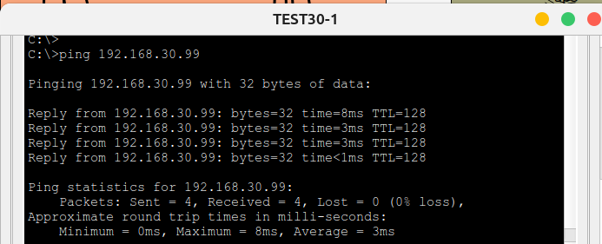
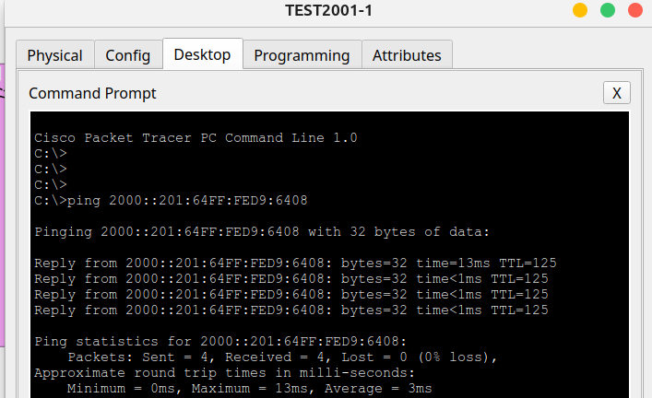

Notes:
==================================================================
Sydney Branch ===================================================
PC0 = 2000::201:97FF:FEB1:9D70
PC0 = 192.168.10.2

LAPTOP0 = 2000::2E0:B0FF:FE43:9953
LAPTOP0 = 192.168.10.8

WEB = 2000::111
WEB = 192.168.10.111
==================================================================
Brisbane Branch =================================================
PC20 = 2001:A::201:63FF:FE02:1179
PC20 = 192.168.30.2

LAPTOP20 = 2001:A::260:70FF:FE99:235C
LAPTOP20 = 192.168.30.9

PC6 ----------------
PC6 = 192.168.40.7
==================================================================

3. Testing Secure Access SSH & Telnet - Local

Commands:
SSH = ssh –l administrator <ip>
Telnet = telnet <ip>

- RT1 192.168.10.1
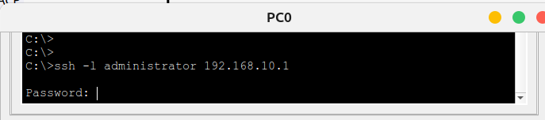

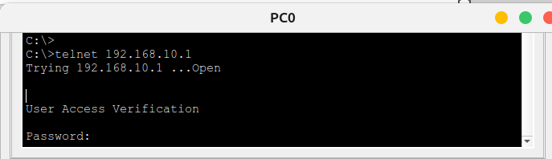

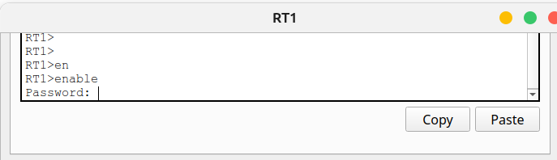

- RT2 2000::3
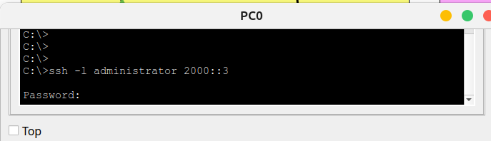

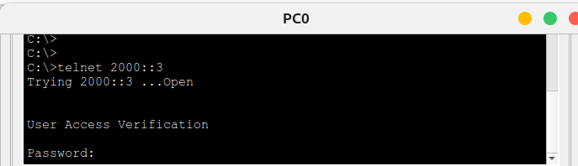

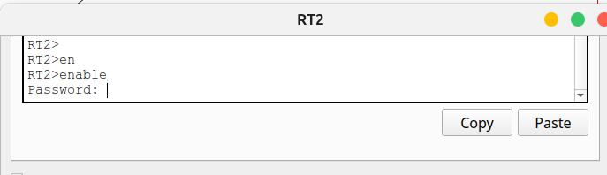

- swm1 VLAN1:192.168.10.97
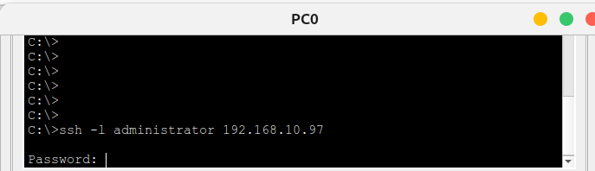

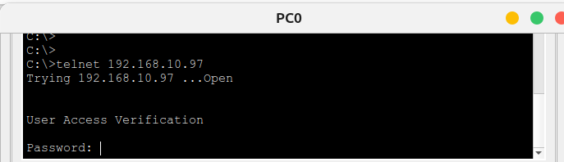

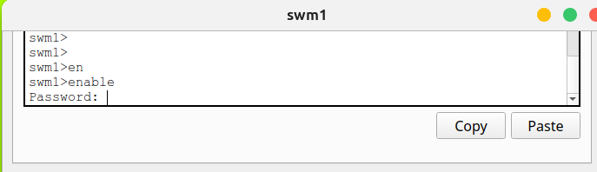

- swm2 VLAN1:192.168.10.98
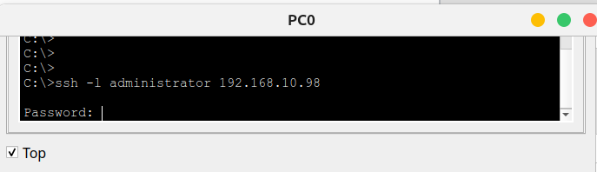

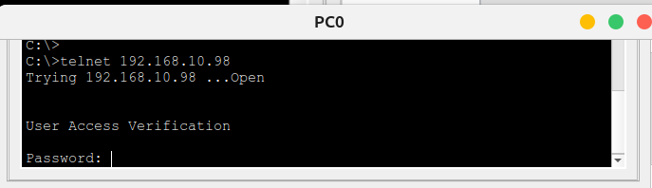

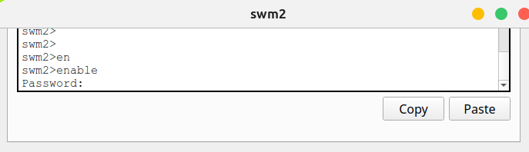

- sw1 VLAN1:192.168.10.96
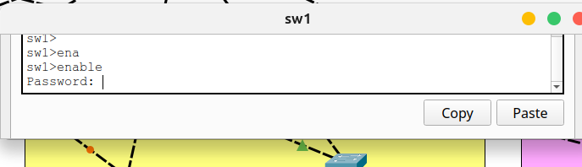

- sw2 VLAN1:192.168.10.95
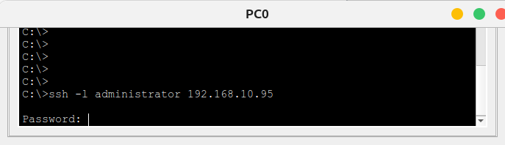

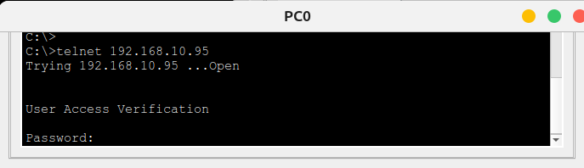

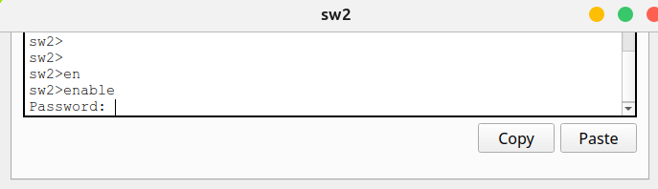

- sw3 VLAN1:192.168.10.94

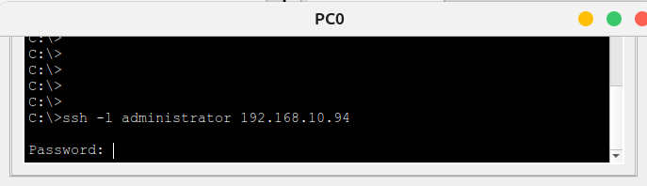

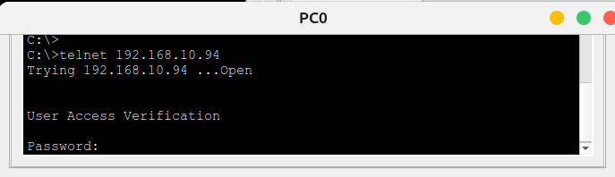

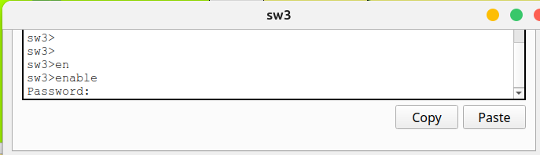

- sw4 VLAN1:192.168.10.93
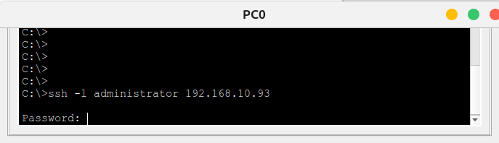

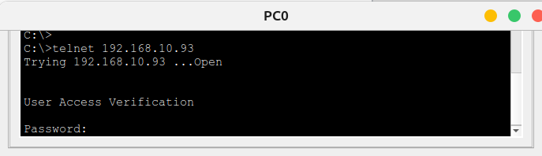

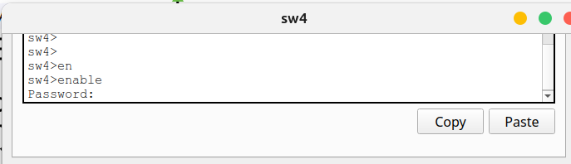

- sw5 VLAN1:192.168.10.92
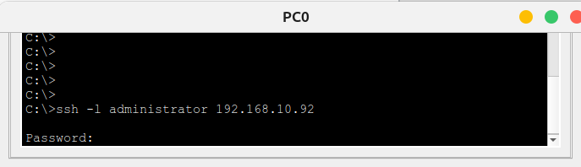

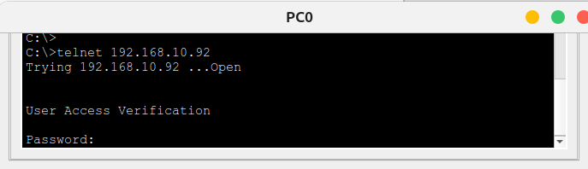

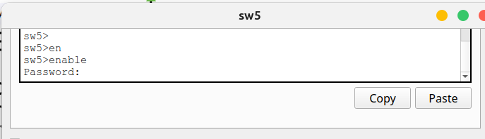
- RT-M 2001:b::2
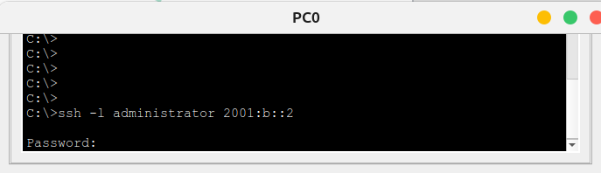

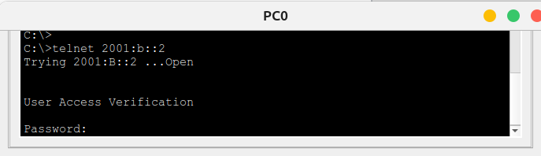

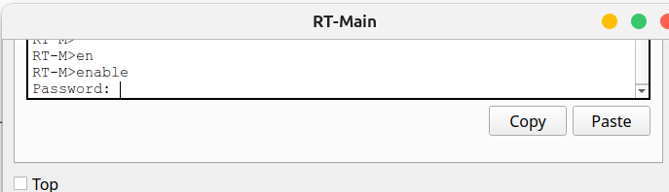
- RT3 2001:a::1
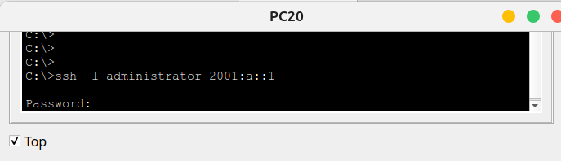

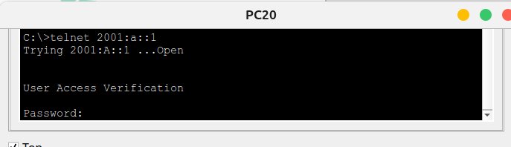

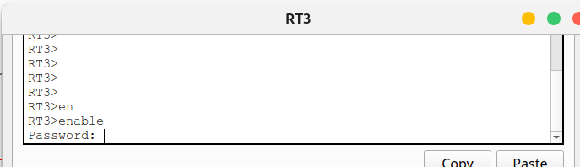
- swm3 VLAN1:192.168.30.97
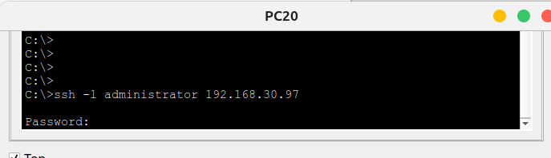

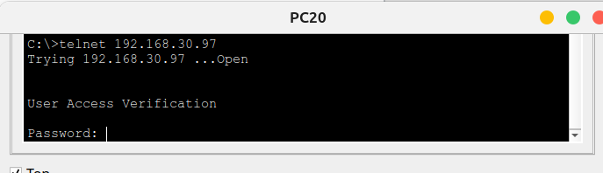

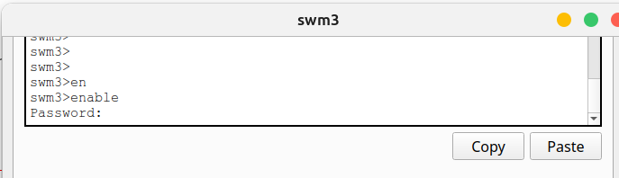
- swm4 VLAN1:192.168.30.98
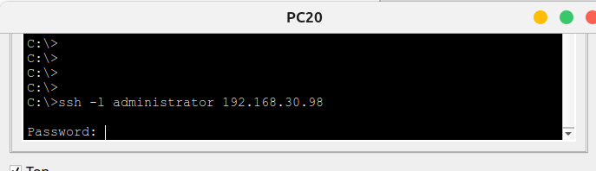

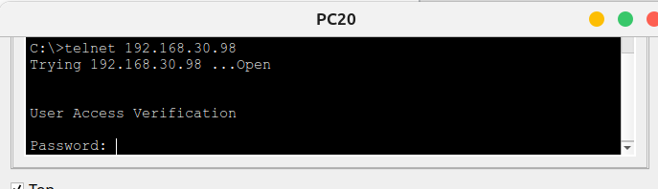

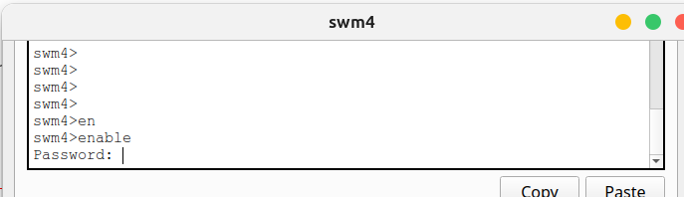
- sw6 VLAN1:192.168.30.96
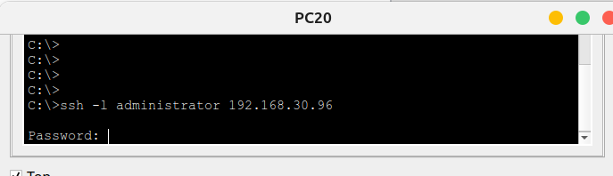

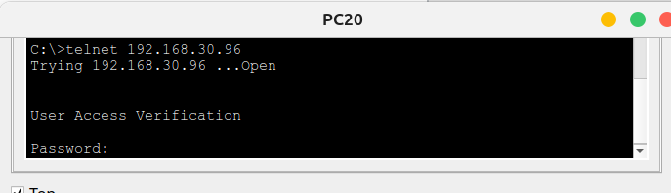

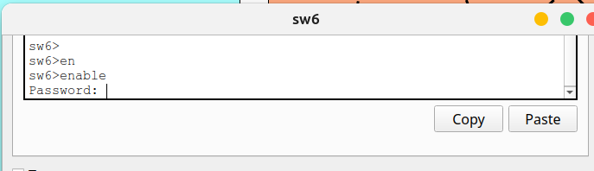
sw7 VLAN1:192.168.30.95
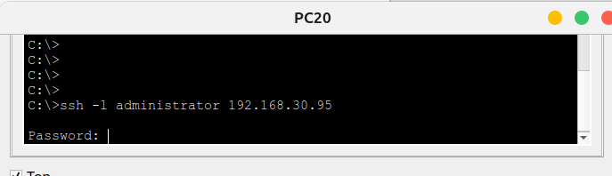

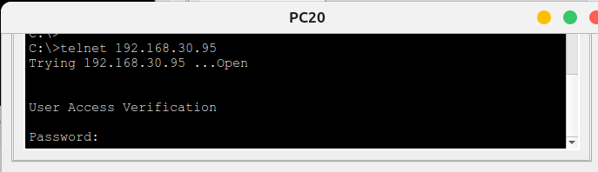

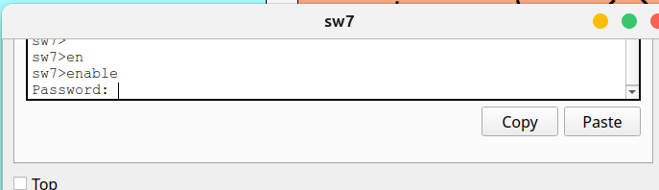
- sw8 VLAN1:192.168.30.94
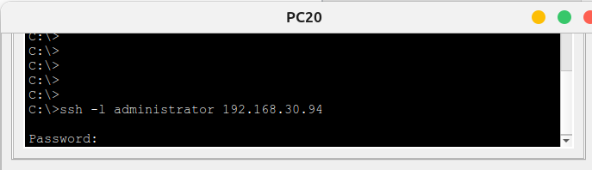

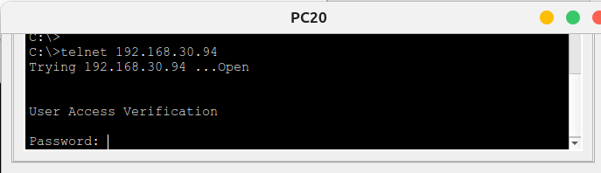

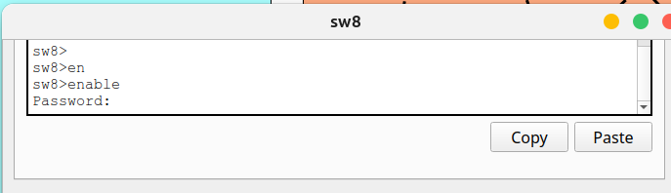
- sw9 VLAN1:192.168.30.93
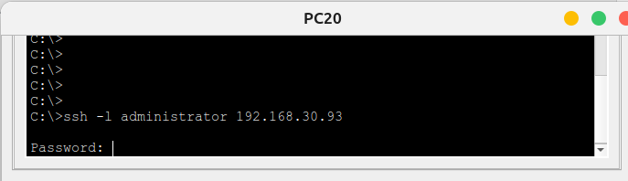

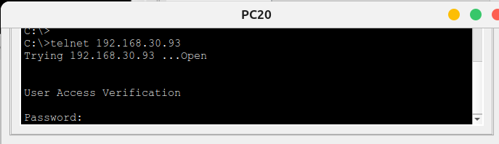

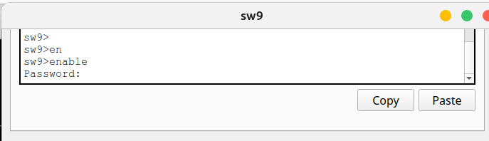
- RT4 192.168.40.1
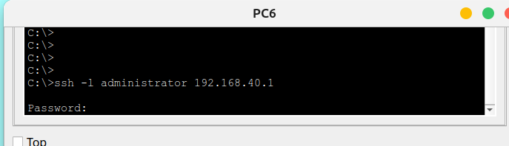

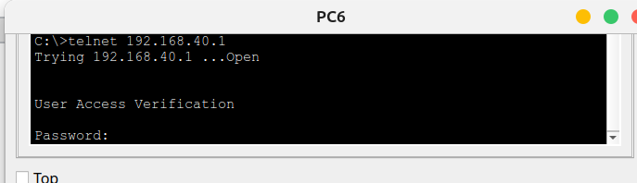

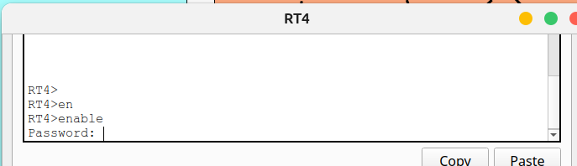
- sw10 VLAN1:192.168.40.98

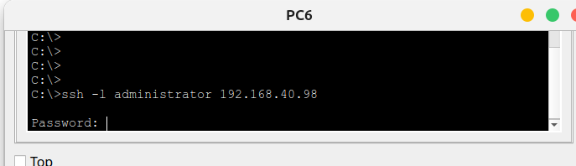
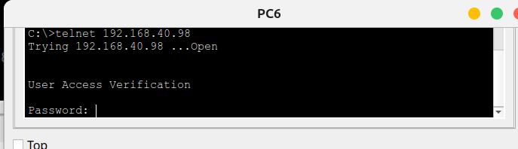

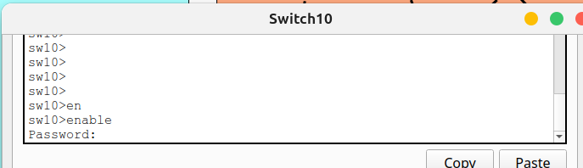
Notes:

=========================================================
RT1 192.168.10.1
RT2 2000::3
swm1 VLAN1:192.168.10.97
swm2 VLAN1:192.168.10.98
sw1 VLAN1:192.168.10.96
sw2 VLAN1:192.168.10.95
sw3 VLAN1:192.168.10.94
sw4 VLAN1:192.168.10.93
sw5 VLAN1:192.168.10.92

RT-M
2001:b::2

RT3 2001:a::1
RT4 192.168.40.1
swm3 VLAN1:192.168.30.97
swm4 VLAN1:192.168.30.98
sw6 VLAN1:192.168.30.96
sw7 VLAN1:192.168.30.95
sw8 VLAN1:192.168.30.94
sw9 VLAN1:192.168.30.93
sw10 VLAN1:192.168.40.92
=========================================================

4. Testing DHCP/DHCPv6 (IPv4/IPv6)

- RT1

New PC configured to DHCP and IPv6 Auto
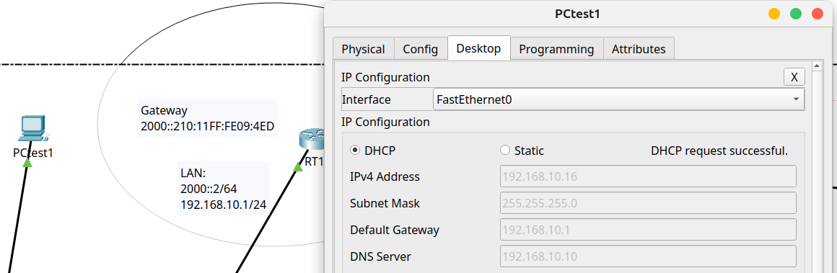

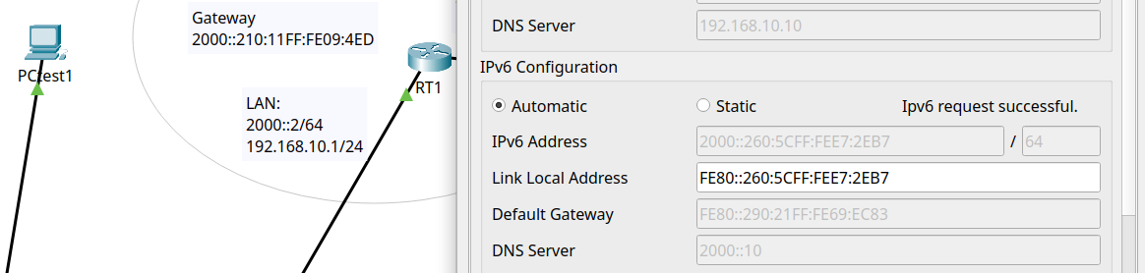

- RT3

New PC configured to DHCP and IPv6 Auto

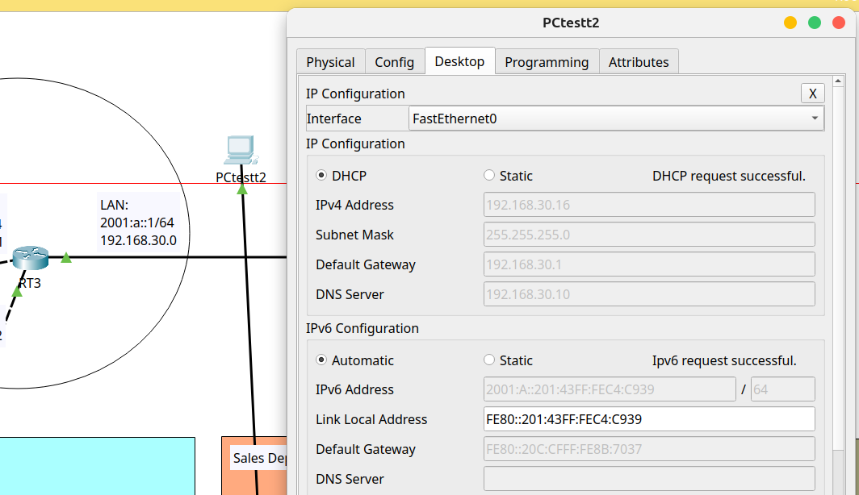

- RT4

New PC configured to DHCP

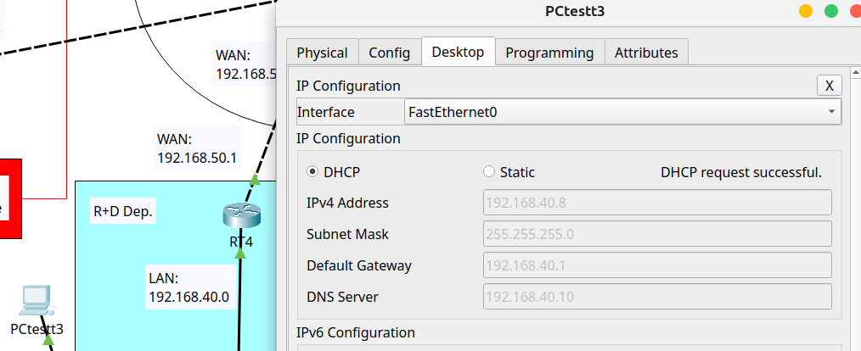

5. Testing LACP (IPv6)

- Summary port-channel Sydney Branch
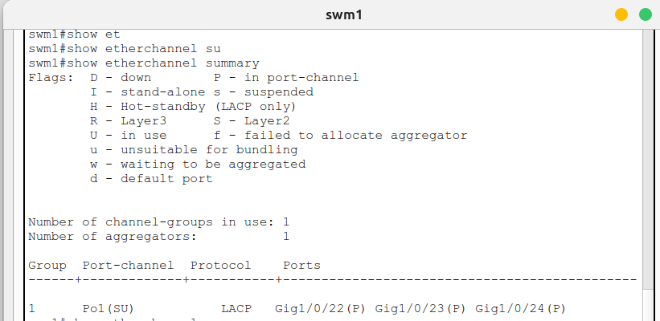

- Summary port-channel Bisbane Branche
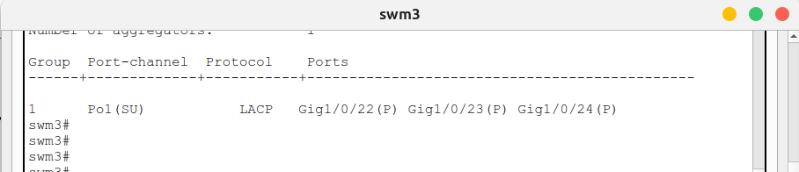

- Testing LACP on Sydney Branch
All connections from swm1 to all local devices was turned off to test redundancy from swm2.

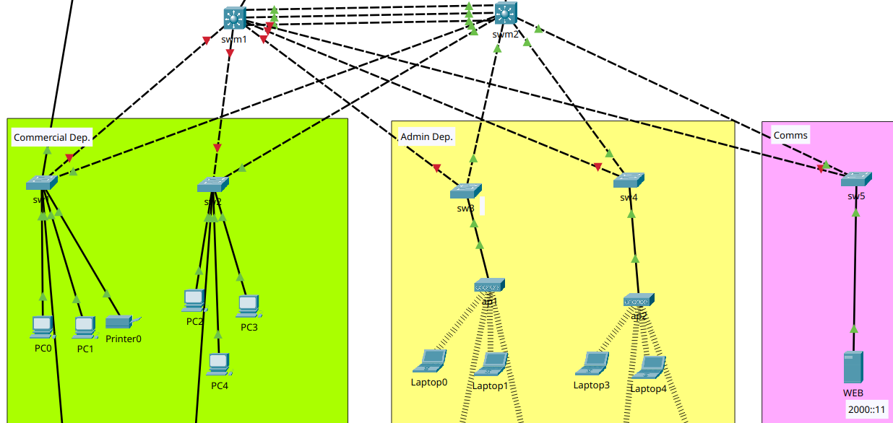

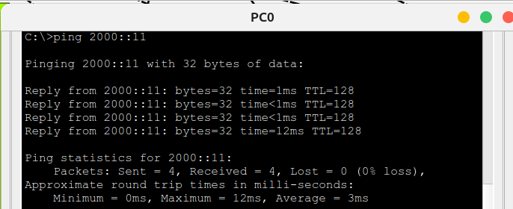
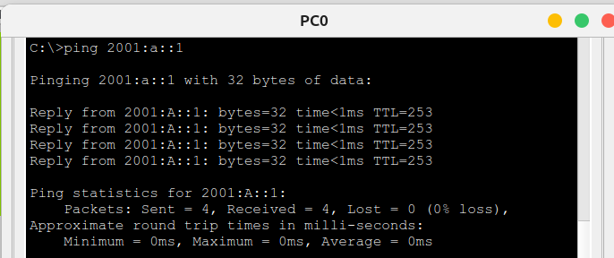
- Testing LACP on Brisbane Branche
All connections from swm3 to all local devices was turned off to test redundancy from swm4.

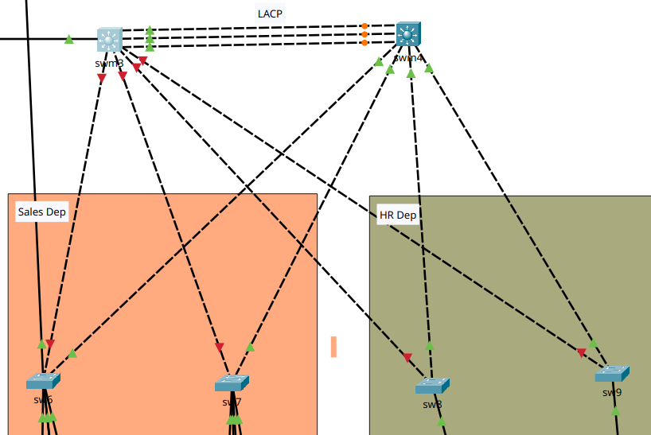

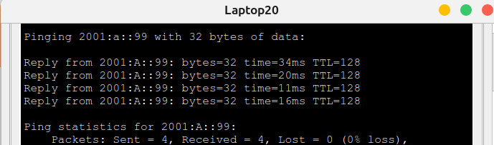

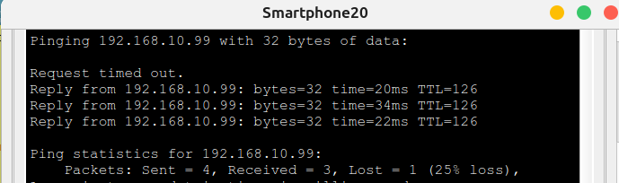

6. Testing HSRPv2 (IPv6)

RT1 is running as a primary (priority 120) and RT2 as a secondary (priority 100).

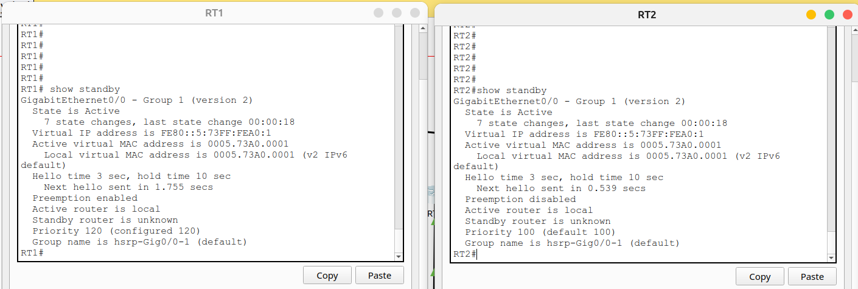

The primary router will be turned off to verify network behaviour.
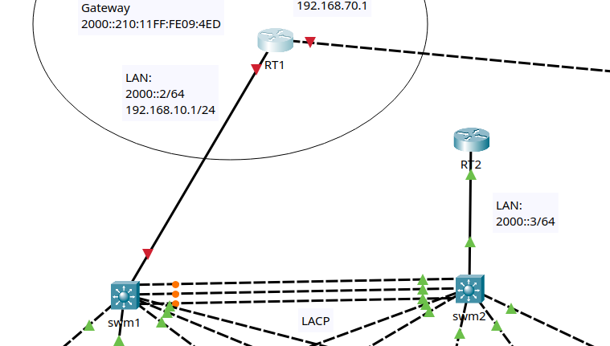

Testing local connection:
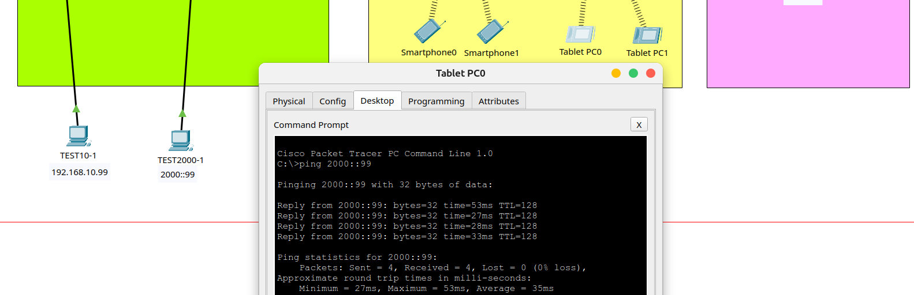

7. Testing OSPF/OSPFv3 (IPv4/IPv6)

Routes between devices are proved by OSPF and OSPFv3.

Communication via WAN interfaces by OSPF

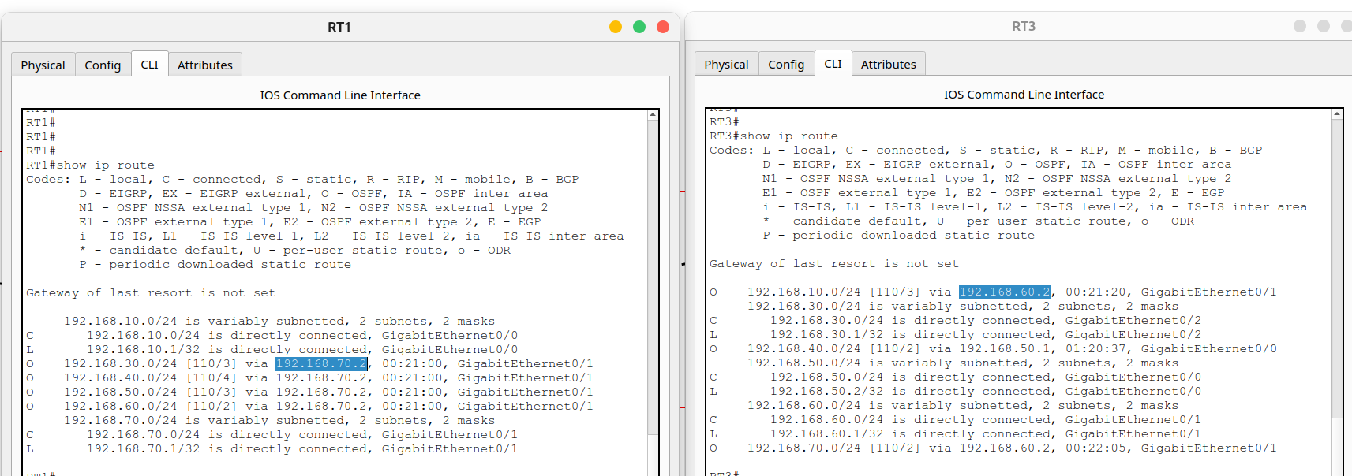

Communication via WAN interfaces by OSPFv3

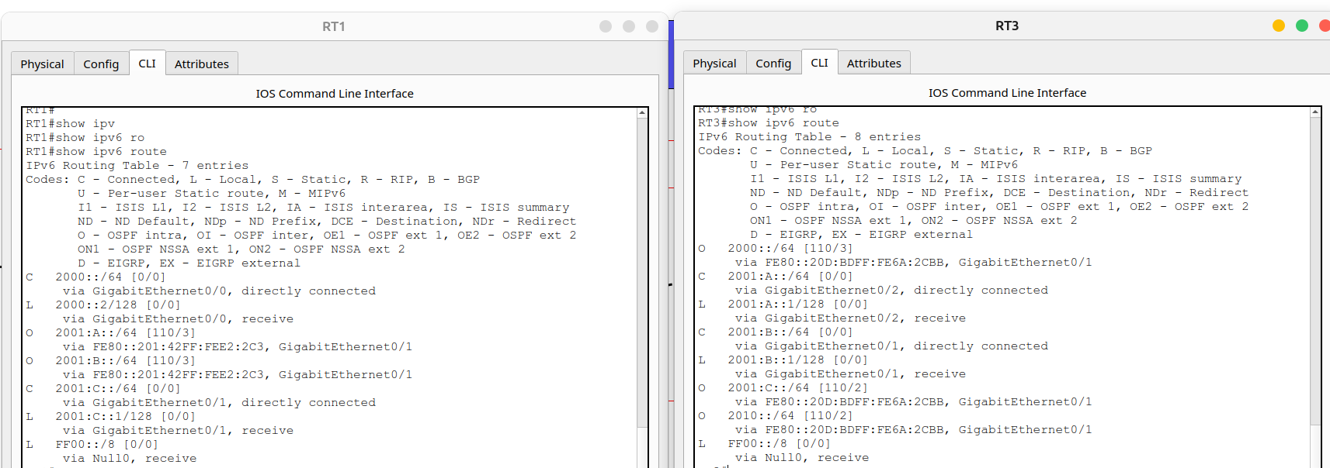

- Bidirectional connectivity testing between Sydney Branch and Brisbane Branch over IPv4
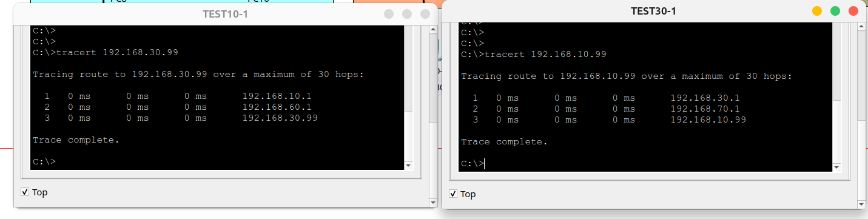

- Bidirectional connectivity testing between Sydney Branch and Brisbane Branch over IPv6

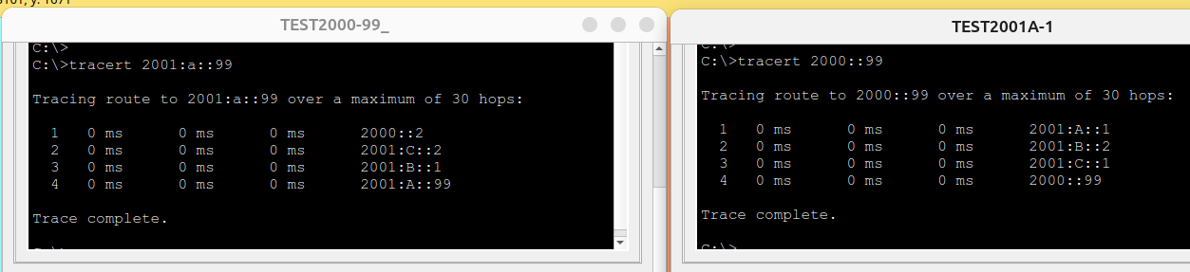

8. Testing ACL (IPv4)

Current Configuration:
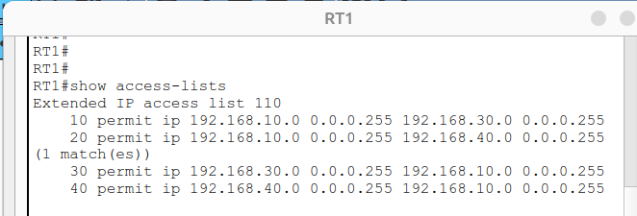
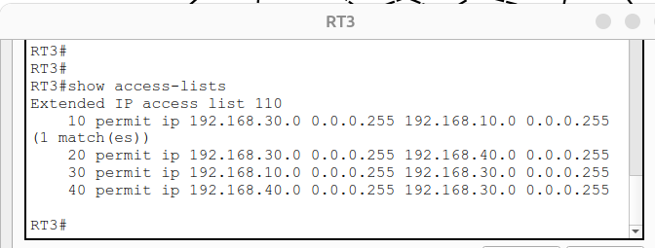
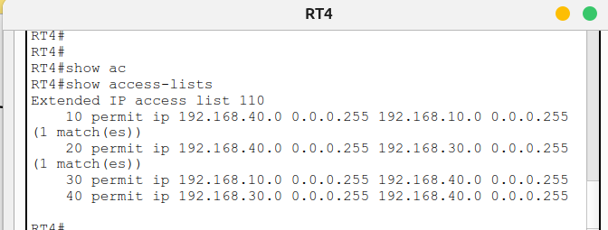

- Test current connectivity from PC-Test (Brisbane IPv4) to PC-Test (Sydney IPv4)
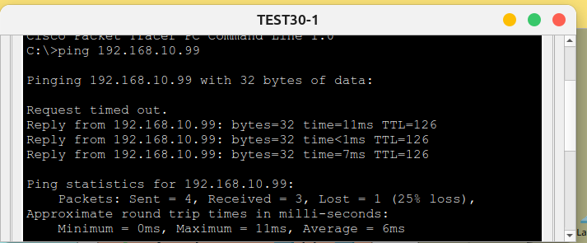

- Test deny connectivity from PC-Test (Brisbane IPv4) to PC-Test (Sydney IPv4)
Rule changed on R1 to deny traffic from 192.168.10.99:

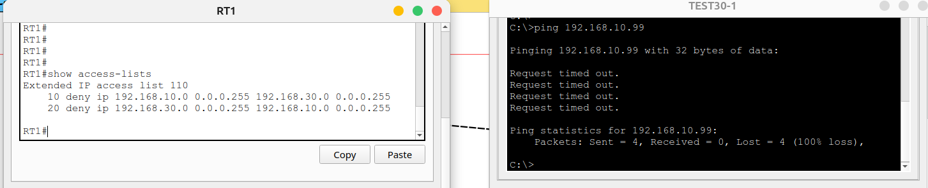

9. Testing VPN Site-To-Site (IPv4)

- Internet connection intercepted by a criminal sniffer (secure by VPN tunnel)

FTP connection from PC on Brisbane Branch to Server on Sydney
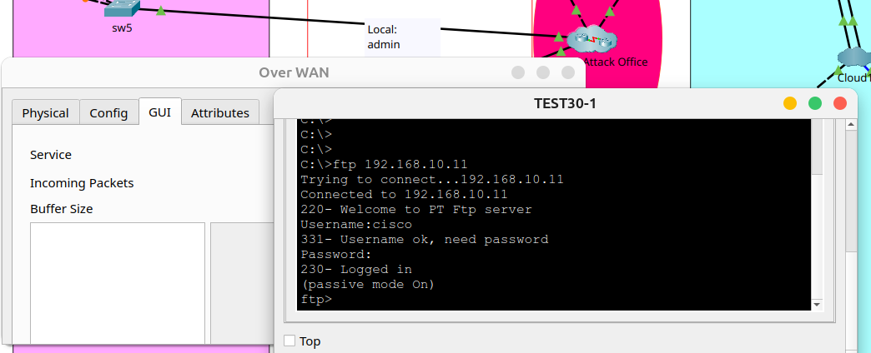

- Local connection intercepted by a criminal sniffer (no secure Lan connection)

FTP connection from PC on Sydney Local Network
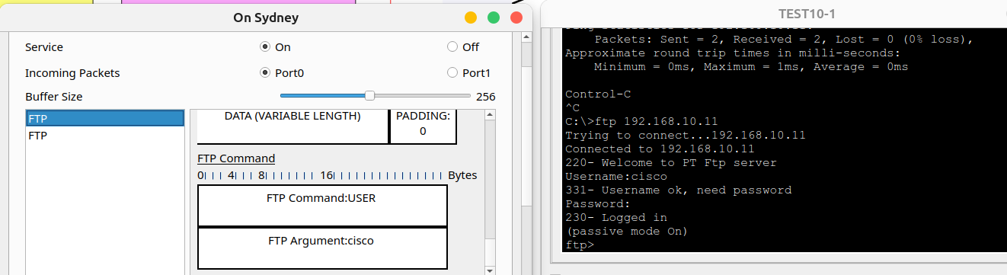

10. Testing Encapsulation PPP (IPv4)

Applied on Routers R1, R2, R3 and ISP. Using of CHAP as an automatic authentication method instead of PAP.

- Testing connection from PC and Laptop to Web
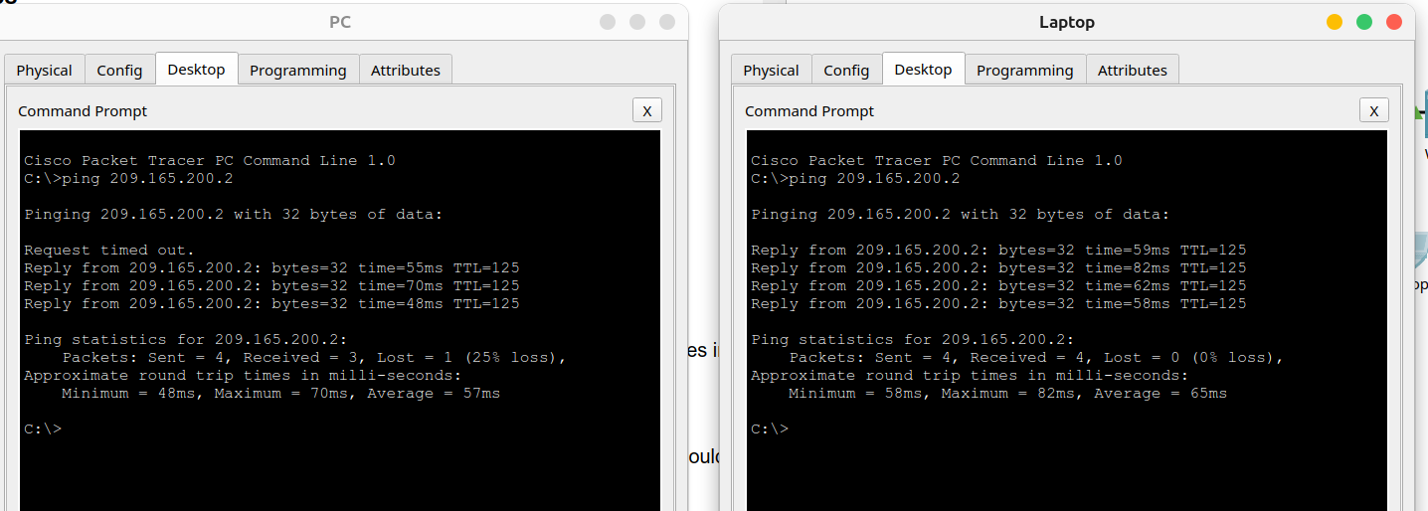

11. Testing Firewall and Single-port

Firewall and single-port tests were performed on the file submitted in class due to extra complexity over my network.

Network:
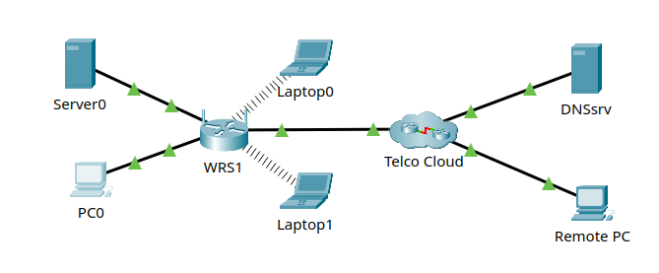

Configuration – Single-Port enabled:
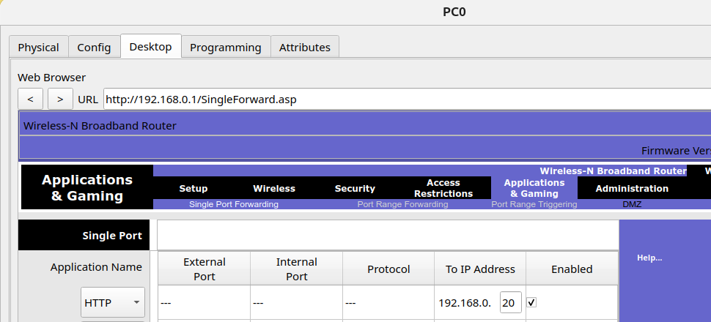

Configuration – DMZ disabled:
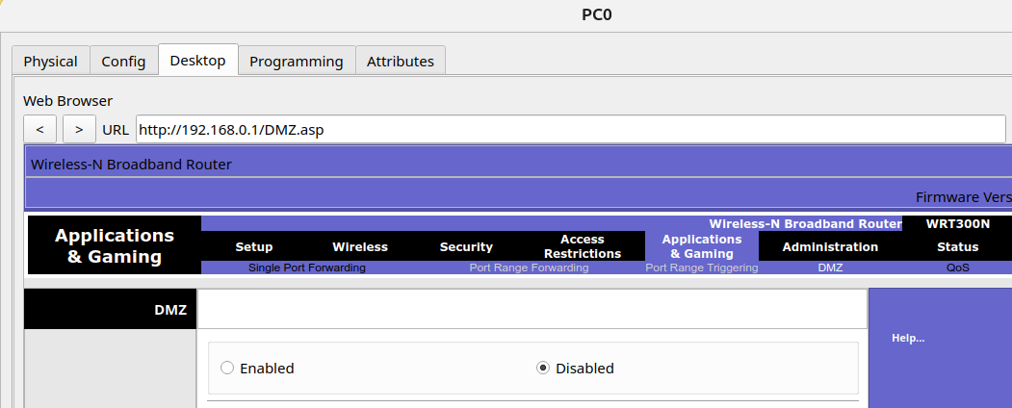

- Testing connection from Remote PC to WEB Server
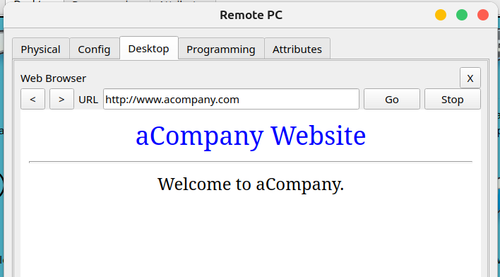

12. Logging Network

Logging network test were performed on the file submitted in class due to extra complexity over my network.

Network:
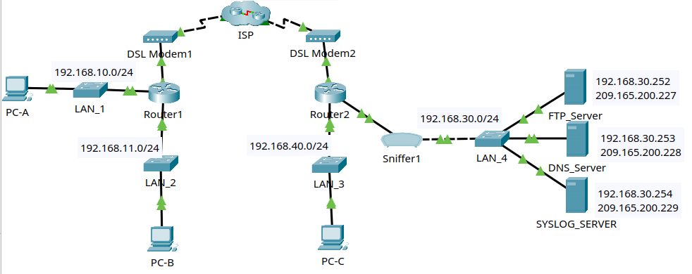

- Vulnerability: FTP messages are being transmitted in clear-text
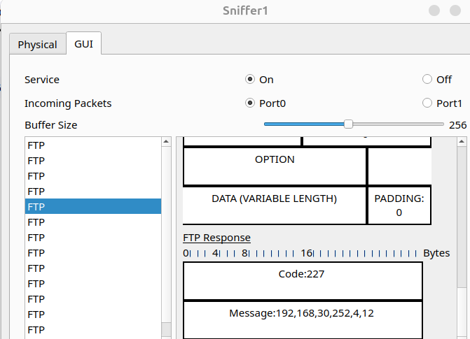

- Echo replies from PC-A/B to R2 its destination is WAN interface of R2
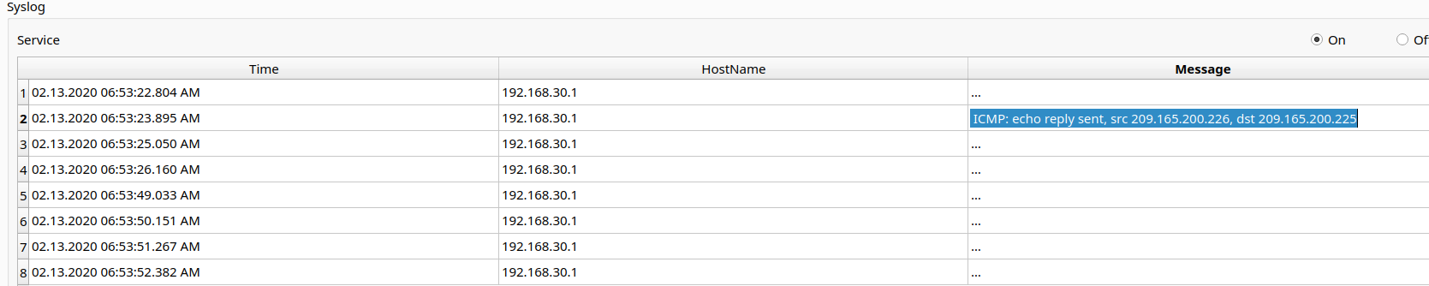

- Echo replies from R2 to PC-C its destination is LAN interface of R2 (because is its local network)
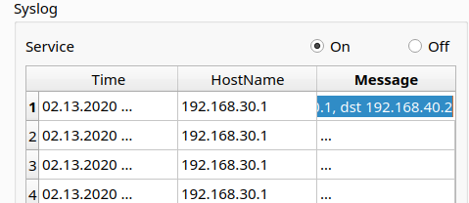

13. Dynamic NAT

Dynamic NAT were performed on the file submitted in class due to extra complexity over my network.

Router 2 (R2)
enable
configure terminal
!
!Standard ACL Configuration
access-list 1 permit 172.16.0.0 0.0.255.255
!
!exit
!Pool for NAT 209.165.200.228 209.165.200.229
ip nat pool micpool 209.165.200.228 209.165.200.229 netmask 255.255.255.252
!
!Mapping ACL with pool
ip nat inside source list 1 pool micpool
!
!Define NAT interfaces for inside and outside
ip nat inside source list 1 pool micpool
interface serial 0/0/1
ip nat inside
exit
!
interface serial 0/0/0
ip nat outside
exit
!

- NAT Translations
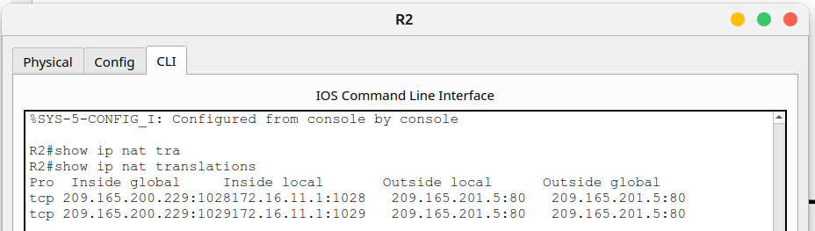

- Testing WEB connection
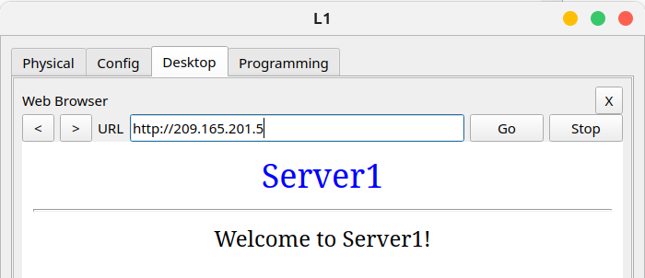

Summary Technologies & Protocols

DHCP (Dynamic Host Configuration Protocol):
Automatically assigns IP, gateway, and DNS addresses to devices on the network

LACP (Link Aggregation Control Protocol):
Combines several physical links to form a single logical link for the purpose of increasing bandwidth also providing redundancy when one of the switches fails.

HSRP (Hot Standby Router Protocol):
Provides redundancy. If the primary router fails, another router automatically takes over, ensuring service continuity.

OSPF (Open Shortest Path First):
Dynamic routing that allows the calculation of the most efficient route to send packets in a network.

ACLs (Access Control Lists):
Rules applied to allow or deny traffic. They are used to filter traffic and improve security.

VPN IPsec (Internet Protocol Security):
Creates secure (encrypted) connections over the Internet between two networks (site-to-site), protecting data confidentiality and integrity.

PPP Authentication (Point-to-Point Protocol Authentication):
Responsible for establishing point-to-point connections and provides encapsulation to facilitate the connection. Also supports authentication mechanisms (CHAP) between two network devices to add an additional layer of security.

Dynamic NAT (Dynamic Network Address Translation):
Map a public network to multiple private networks on a WAN to communicate with external IPs.

Bibliography

- Network System: Gurutech Networking Training - Secure Network Training
- DHCPv6 Router: Gurutech Networking Training - DHCPv6
- DHCPv6 stateless-stateful: ShefferKimanzi - DCHP v6 configuration
- LACP: ITExamAnswers.net - Configure EtherChannel l
- HRSP v2 IPv6: Packet Tracer Network - HSRP Configuration
- IPCisco.com: ADSL IPv6
- ACLs: Packet Tracer Network - ACLs
- OSPFv3: Networking Academy - IPv6 OSPFv3
- OSPf: Computer Networking - OSPF
- VPN IPsec tunnel (site-to-site): Abdullah Irfan, Medium, VPN tunnel
- VPN site-to-site, IPsec: Gurutech Networking Training - VPN IPsec
- SSH: Sheffer Kimanzi, Configuring ssh
- Telnet: Sheffer Kimanzi, Configuring telnet
- Dynamic NAT: ComputerNetworkingNotes - Dynamic NAT

ISSUES:
- I was using wrong gateway in IPv6, gateway must be ID IPv6 network. Now, connection from/to 192.168.40.1 is working.

